# TABLE OF CONTENT

TABLE OF CONTENT 1

CHAPTER 1. SURVEY OF STATUS AND DETERMINATION OF REQUIREMENTS 4

1.1. SURVEY OF CURRENT STATUS 4

1.1.1. Shopee 4

1.1.1.1. Introduction 4

1.1.1.2. Advantages 5

1.1.1.3. Disadvantages 5

1.1.2. Tiki 5

1.1.2.1. Introduction 5

1.1.2.2. Advantages 6

1.1.2.3. Disadvantages 6

1.1.3. YaMe 6

1.1.3.1. Introduction 6

1.1.3.2. Advantages 7

1.1.3.3. Disadvantages 7

1.2. DETERMINATION OF REQUIREMENTS 8

1.2.1. Functional requirements 8

1.2.1.1. Professional function requirements 8

1.2.1.2. System function requirements 10

1.2.2. Non-functional requirements 11

CHAPTER 2. REQUIREMENT MODELING 13

2.1. DEFINE USECASE 13

2.1.1. Actor 13

2.1.2. Use case 14

2.2. USE CASE DIAGRAM 19

2.3. USE CASE SPECIFICATION 19

2.3.1. Recover password 19

2.3.2. Manage personal information 20

2.3.2.1. Add address 21

2.3.2.2. Edit address 21

2.3.3. Add product to cart 22

2.3.4. Manage cart 24

2.3.4.1. Edit product quantity from cart 24

2.3.4.2. Edit product option from cart 25

2.3.4.3. Remove product from cart 25

2.3.5. Order 26

2.3.5.1. Create order 26

2.3.5.2. Pay 27

2.3.6. Manage personal orders 28

2.3.6.1. View personal order detail 28

2.3.6.2. Cancel personal order 29

2.3.7. View system notifications 29

2.3.8. Manage users 30

2.3.8.1. View user information 30

2.3.8.2. Authorize account 31

2.3.8.3. Edit user account status 31

2.3.9. Manage products 32

2.3.9.1. Add new product 32

2.3.9.2. Edit product information 33

2.3.9.3. Manage product options 33

2.3.10. Manage orders 37

2.3.10.1. View order detail 38

2.3.10.2. Approve order 38

2.3.10.3. Confirm received order 39

2.3.10.4. Confirm failed order 39

2.3.10.5. Cancel order 40

2.3.11. Create in-store order 40

2.3.11.1. Create in-store order 41

CHAPTER 3. SOFTWARE DESIGN 42

3.1. SYSTEM DESIGN 42

3.1.1. Work flow 42

3.1.1.1. Online ordering 42

3.1.1.2. Create order in store 42

3.1.2. Sequence diagram 43

3.1.2.1. Login 43

3.1.2.2. Recovery password 44

3.1.2.3. Change password 46

3.1.2.4. Add product to cart 47

3.1.2.5. Create Order 48

3.1.2.6. Manage personal order 49

3.1.2.7. Manage orders 49

3.1.2.8. Create instore order 52

3.2. DATABASE DESIGN 53

3.2.1. users 53

3.2.2. brands 55

3.2.3. categoryGroups 55

3.2.4. categories 56

3.2.5. products 56

3.2.6. sizeOptions 57

3.2.7. colorOptions 57

3.2.8. quantityOption 58

3.2.9. comments 58

3.2.10. rates 59

3.2.11. carts 60

3.2.12. orders 60

3.2.13. orderDetail 62

3.2.14. notifications 63

3.2.15. Messenger 64

3.2.16. Messages 65

3.3. INTERFACE DESIGN 65

3.3.1. List of screens and screen flow on website 65

3.3.2. Screen details on website 67

3.3.2.1. Customer pages 67

3.3.2.2. Admin Pages 85

3.3.3. List of screens and screen flow on mobile application 96

CHAPTER 4. INSTALLATION AND TESTING 97

4.1. INSTALL APPLICATION 97

4.2. SOFTWARE TESTING 100

4.2.1. Registration function 100

4.2.2. Login function 102

4.2.3. Password change function 103

4.2.4. Product search function 103

4.2.5. Ordering functions 104

4.2.6. Product list filter by condition function 105

4.2.7. Image change function when changing product colors 106

4.2.8. Product rating function 107

4.2.9. Product comment function 107

# SURVEY OF STATUS AND DETERMINATION **OF REQUIREMENTS**



## SURVEY OF CURRENT STATUS

Fashion has always been an essential part of life. The business of fashion items has also become active since then, especially on the e-commerce platform - which is the current business trend. Beginners without capital or experience want to start with e-commerce. Or stores that want to open an e-commerce channel. Therefore, an e-commerce channel that is supported on both website and mobile platforms is essential.

Most people today are either busy, or lazy with the help of technology, or for other reasons that make them less likely to visit offline stores. Instead, they often shop online. Online shopping also has many benefits, such as more convenience, or sometimes the price will be cheaper. Therefore, online shopping has recently become a great demand of customers.

Here is the work of the e-commerce system for the store chain required to provide users:

- SuperAdmin: manage their stores in detail such as: view information, manage products of stores.

- Admin: process orders, reply comments.

- Customers: view, comment, rate and order easily via computer or phone.

### Shopee

#### Introduction

Shopee is the leading e-commerce platform in Southeast Asia, headquartered in Singapore and a subsidiary of Sea company, formerly Garena (owners of brands such as: Garena, Foody, Now, Airpay). from 2015 and at the present time has been present in a total of 7 Asian countries including: Singapore; Malaysia; Thailand; Taiwan; Indonesia; Vietnam, and the Philippines.

Shopee was born to create an e-commerce platform to provide customers with an easy, safe and convenient online shopping experience by fast payment and shipping process.

Besides, Shopee will create a business environment for individuals, organizations and businesses that want to promote, market and distribute their products to customers. Just a few simple steps to register and upload, describe products, everyone can open a store on Shopee and this is also an online business opportunity for any individual, any organization.

Present in Vietnam around August 2016. Up to the present time, Shopee can be seen as superior to its predecessors such as Lazada, Tiki, Adayroi, Lotte….

#### Advantages

* Provide almost all the professional functions that users need such as: preferential sale prices, regular discounts, policies to protect both buyers and sellers.
* Intuitive user interface, provide product information fully as well as search filters
* Offers many forms of delivery and payment, including payment by Shopee coin, a virtual currency of Shopee and through the e-wallet AirPay
* Provide many login methods

#### Disadvantages

Because there are too many functions, leading to a decrease in website performance, in particular the response speed and page load are quite slow.

### Tiki

#### Introduction

As one of the largest e-commerce sites in Vietnam, according to iPrice's statistics in the second quarter of 2019, Tiki ranks second among e-commerce exchanges in Vietnam, just behind Shopee (in terms of visits).

Tiki operates under the business model of B2C (Business to Customer), which means Tiki is the intermediary connecting consumers and businesses / sellers together. Creating a friendly, convenient and easy online shopping environment for both buyers and sellers.

Brands / businesses / traders / sellers will register to open booths on Tiki to sell their products. Besides, Tiki himself also directly sells and distributes many products of genuine brands through TikiTrading booth.

Front-end:

* Website using ReactJS.
* Phones using React Native.

#### Advantages

* Website has a scientific and reasonable layout
* Page loading speed is quite fast
* Take advantage of ReactJS human resources for React Native development
* Easy to maintain

#### Disadvantages

* The interface is confusing for the first-time visitor
* The size of the website is about 3MB (2018)
* Small photo but big size

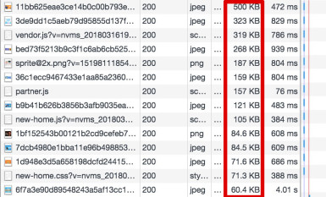

Image 2.1.Size of photo on Tiki

* Css is quite heavy

### YaMe

#### Introduction

YaMe is a Vietnamese fashion brand for young people. YaMe means You are My everything.

YaMe has been launching more trendy collections to contribute to the fashion trend of contemporary youth! Quickly and promptly catch the latest trends of the world to bring to Vietnam...

Do not always follow the trend, lose yourself. YaMe has always kept the values it has built and developed for a long time, the highlights that have brought customers to YaMe during the past time. In addition to investment products and picky faces, YaMe still regularly launches casual designs at great prices for students.

#### Advantages

* Fast page loading speed
* Limit the maintenance of lead over time

#### Disadvantages

* Long application development time.
* Suitable for websites that require high speed, light. Not suitable for websites that ask for fast development time.
* Requires high knowledge as well as skills
* Difficulty in website maintenance.
* Complicated and difficult to use user interface



## DETERMINATION OF REQUIREMENTS

### Functional requirements

#### Professional function requirements

##### Guest

* **View homepage**
  + View poster
  + View Featured products
* **Search product**
* **View product detail and view reviews**
* **Register**
* **Login:**
  + Login with website account
  + Login with Google
  + Login with Facebook
  + Recover password

##### Customer

* **View homepage:**
  + View poster
  + View recommended products
  + View Featured products
* **Search product**
* **View product detail and reviews**
* **Comment and rate**
  + Comment and rate
  + Reply comment and rate
  + Edit and remove comment and rate
* **Manage personal information:**
  + Edit personal information
  + Add, edit, delete addresses
  + Add avatar
  + Edit avatar
  + Change password
* **Manage cart:**
* Add product to cart
* Remove product from cart
* Edit product quantity
* Edit product type
* **Order:**
* Order
* Pay
* **Manage orders:**
  + View personal order list
  + Search orders
  + View order detail
  + Cancel order
* **View notifications**
* **Chat**
* **Logout**

##### Admin

* **Including customer functions**
* **View system notifications**
* **Manage orders:**
  + View order list
  + Search orders
  + View order detail and order status
  + Approve order
  + Confirm received order
  + Confirm failed order
  + Cancel order

##### SuperAdmin

* **Including Admin functions**
* **Manage Users:**
  + View user list
  + Search users
  + View user information
  + Authorize account
  + Disable user account
* **Manage brands:**
  + Add new brand
  + View list brand
  + Edit brand information
  + Disable brand
* **Manage category groups:**
  + Add new category group
  + View list category group
  + Edit category group information
  + Disable category group
* **Manage categories:**
  + Add new category
  + View list category
  + Edit category group
  + Disable category
* **Manage products:**
  + Add new product
  + View list product
  + Search products
  + View product detail
  + Edit product information
  + Disable product
* **Manage product options:**
  + Add new product option
  + View list product option
  + Edit product option information

#### System function requirements

* **Authorization:**
* Guest: Only view homepage, search products, view product detail, view product reviews, signup and login
* Customer: View homepage, search products, view product detail, view reviews, comment and rate, chat, manage personal information, add product to card, manage cart, order and manager order.
* Admin: Manage orders and have same functions as Customer
* SuperAdmin: Manage users, manage brand, manage products, manage product options and have same functions as Admin
* **Notification:**
* Always be informed when the operation succeeds or fails
* **Security:**
* Always check the permissions before working with data
* Against basic attacks such as: xss, sql injection, CSRF, ...
* **Storage:**
* Users
* Admins
* Chats
* Images
* Brands
* Categories
* Category groups
* Products
* Orders

### Non-functional requirements

* **Usability:**
* Easy-to-see, user-friendly interface
* Fully functional
* Easy to manipulate
* **Effectiveness:**
* Fast and efficient search speeds
* Fast page loading speed
* **Compatibility:**
* To meet multiple platforms and devices
* **Development:**
* Easy to develop applications, and use in trading other products
  + **Maintainment:**
* Easy to operate
* Easy maintenance and repair

# REQUIREMENT MODELING



## DEFINE USECASE

### Actor

Table 3.1. Actor

|  |  |  |  |  |  |
| --- | --- | --- | --- | --- | --- |
| **No** | **Use case** | **SuperAdmin Actor** | **Admin Actor** | **Customer Actor** | **Guest Actor** |
| 1 | Register |  |  |  | x |
| 2 | Login |  |  |  | x |
| 3 | Logout | x | x | x |  |
| 4 | Change password | x | x | x |  |
| 5 | Recover password | x | x | x |  |
| 6 | Manage personal information | x | x | x |  |
| 7 | View personal notifications | x | x | x | x |
| 8 | Chat | x | x | x |  |
| 9 | View homepage | x | x | x | x |
| 10 | Search product | x | x | x | x |
| 11 | View product detail | x | x | x | x |
| 12 | Comment and rate | x | x | x |  |
| 13 | Add product to cart | x | x | x |  |
| 14 | Manage cart | x | x | x |  |
| 15 | Order | x | x | x |  |
| 16 | Manage personal orders | x | x | x |  |
| 17 | View system notifications | x | x |  |  |
| 18 | Manage users | x |  |  |  |
| 19 | Manage brands | x |  |  |  |
| 20 | Manage category groups | x |  |  |  |
| 21 | Manage categories | x |  |  |  |
| 22 | Manage products | x |  |  |  |
| 23 | Manage orders | x | x |  |  |
| 24 | Create in-store order | x | x |  |  |
| 25 | View statistics | x |  |  |  |

### Use case

Table 3.2. Use case

|  |  |  |  |  |  |
| --- | --- | --- | --- | --- | --- |
| **No** | **Use case name** | | | | **Use case ID** |
| 1 | Register | | | | UC_1 |
| 2 | Login | | | | UC_2 |
|  | 2.1 | Login with account | | | UC_2.1 |
|  | 2.2 | Login with Google | | | UC_2.2 |
|  | 2.3 | Login with Facebook | | | UC_2.3 |
| 3 | Logout | | | | UC_3 |
| 4 | Change password | | | | UC_4 |
| 5 | Recover password | | | | UC_5 |
| 6 | Manage personal information | | | | UC_6 |
|  | 6.1 | View personal information | | | UC_6.1 |
|  | 6.2 | Edit personal information | | | UC_6.2 |
|  | 6.3 | Add avatar | | | UC_6.3 |
|  | 6.4 | Edit avatar | | | UC_6.4 |
|  | 6.5 | Add address | | | UC_6.5 |
|  | 6.6 | Edit Address | | | UC_6.6 |
| 7 | View personal notifications | | | | UC_7 |
| 8 | Chat | | | | UC_ |
|  | 8.1 | Chat with other users | | | UC_8.1 |
|  | 8.2 | Chat with customer service | | | UC_8.2 |
|  | 8.3 | Chat with virtual assistant | | | UC_8.3 |
| 9 | View homepage | | | | UC_9 |
|  | 9.1 | View poster | | | UC_9.1 |
|  | 9.2 | View hot products | | | UC_9.2 |
|  | 9.3 | View recommended products | | | UC_9.3 |
| 10 | Search products | | | | UC_10 |
|  | 10.1 | View all products | | | UC_10.1 |
|  | 10.2 | Search products by name | | | UC_10.2 |
|  | 10.3 | Search products by category group | | | UC_10.3 |
|  | 10.4 | Search products by category | | | UC_10.4 |
|  | 10.5 | Sort products by option | | | UC_10.5 |
|  | 10.6 | Filter products by price | | | UC_10.6 |
| 11 | View product detail | | | | UC_11 |
| 12 | Comment and rate | | | | UC_12 |
|  | 12.1 | Comment | | | UC_12.1 |
|  | 12.2 | Reply comment | | | UC_12.2 |
|  | 12.3 | Edit comment | | | UC_12.3 |
|  | 12.4 | Remove comment | | | UC_12.4 |
|  | 12.5 | Rate | | | UC_12.5 |
|  | 12.6 | Replay rate | | | UC_12.6 |
|  | 12.7 | Edit rate | | | UC_12.7 |
|  | 12.8 | Remove rate | | | UC_12.8 |
| 13 | Add product to cart | | | | UC_13 |
| 14 | Manage cart | | | | UC_14 |
|  | 14.1 | Edit product quantity | | | UC_14.1 |
|  | 14.2 | Edit product option | | | UC_14.2 |
|  | 14.3 | Remove product | | | UC_14.3 |
| 15 | Order | | | | UC_15 |
|  | 15.1 | Create order | | | UC_15.1 |
|  |  | 15.1.1 | | Choose products from cart | UC_15.1.1 |
|  |  | 15.1.2 | | Choose payment method | UC_15.1.2 |
|  |  | 15.1.3 | | Choose receive method | UC_15.1.3 |
|  |  | 15.1.4 | | Choose receive address | UC_15.1.4 |
|  |  | 15.1.5 | | Choose shipping address | UC_15.1.5 |
|  |  | 15.1.6 | | View total price and shipping fee | UC_15.1.6 |
|  | 15.2 | Pay | | | UC_15.2 |
| 16 | Manage personal orders | | | | UC_16 |
|  | 16.1 | View personal order list | | | UC_16.1 |
|  | 16.2 | Search personal orders | | | UC_16.2 |
|  |  | 16.2.1 | | Search personal orders by order ID | UC_16.2.1 |
|  |  | 16.2.2 | | Search personal orders by product name | UC_16.2.2 |
|  |  | 16.2.3 | | Search personal orders by customer name | UC_16.2.3 |
|  |  | 16.2.4 | | Search personal orders by customer phone number | UC_16.2.4 |
|  | 16.3 | View personal order detail | | | UC_16.3 |
|  | 16.4 | Cancel order | | | UC_16.4 |
| 17 | View system notifications | | | | UC_17 |
| 18 | Manage users | | | | UC_18 |
|  | 18.1 | View user list | | | UC_18.1 |
|  | 18.2 | Search users | | | UC_18.2 |
|  |  | 18.2.1 | | Search user by name | UC_18.2.1 |
|  |  | 18.2.2 | | Search user by role | UC_18.2.2 |
|  | 18.3 | View user information | | | UC_18.3 |
|  | 18.4 | Authorize account | | | UC_18.4 |
|  | 18.5 | Disable user account | | | UC_18.5 |
| 19 | Manage brands | | | | UC_19 |
|  | 19.1 | Add new brand | | | UC_19.1 |
|  | 19.2 | View brand list | | | UC_19.2 |
|  | 19.3 | Search brands | | | UC_19.3 |
|  | 19.4 | Edit brand information | | | UC_19.4 |
|  | 19.5 | Disable brand | | | UC_19.5 |
| 20 | Manage category groups | | | | UC_20 |
|  | 20.1 | Add new category group | | | UC_20.1 |
|  | 20.2 | View category group list | | | UC_20.2 |
|  | 20.3 | Search category groups | | | UC_20.3 |
|  | 20.4 | Edit category group information | | | UC_20.4 |
|  | 20.5 | Disable category group | | | UC_20.5 |
| 21 | Manage categories | | | | UC_21 |
|  | 21.1 | Add new category | | | UC_21.1 |
|  | 21.2 | View category list | | | UC_21.2 |
|  | 21.3 | Search categories | | | UC_21.3 |
|  | 21.4 | Edit category information | | | UC_21.4 |
|  | 21.5 | Disable category | | | UC_21.5 |
| 22 | Manage products | | | | UC_22 |
|  | 22.1 | Add new product | | | UC_22.1 |
|  | 22.2 | View product list | | | UC_22.2 |
|  | 22.3 | Search products | | | UC_22.3 |
|  |  | 22.3.1 | | Search product by product name | UC_22.3.1 |
|  |  | 22.3.2 | | Search product by product category | UC_22.3.2 |
|  | 22.4 | View product information | | | UC_22.4 |
|  | 22.5 | Edit product information | | | UC_22.5 |
|  | 22.6 | Manage product options | | | UC_22.6 |
|  |  | 22.6.1 | | Create color option | UC_22.6.1 |
|  |  | 22.6.2 | | View color option list | UC_22.6.2 |
|  |  | 22.6.3 | | Edit color option | UC_22.6.3 |
|  |  | 22.6.4 | | Create size option | UC_22.6.4 |
|  |  | 22.6.5 | | View size option list | UC_22.6.5 |
|  |  | 22.6.6 | | Edit size option | UC_22.6.6 |
|  |  | 22.6.7 | | Create quantity option | UC_22.6.7 |
|  |  | 22.6.8 | | View quantity option list | UC_22.6.8 |
|  |  | 22.6.9 | | Edit quantity option | UC_22.6.9 |
|  | 22.7 | Disable product | | | UC_22.7 |
| 23 | Manage orders | | | | UC_23 |
|  | 23.1 | View order list | | | UC_23.1 |
|  | 23.2 | Search orders | | | UC_23.2 |
|  |  | 23.2.1 | | Search by product ID | UC_23.2.1 |
|  |  | 23.2.2 | | Search by product name | UC_23.2.2 |
|  |  | 23.2.3 | | Search by customer name | UC_23.2.3 |
|  |  | 23.2.4 | | Search by customer phone number | UC_23.2.4 |
|  | 23.3 | View order detail | | | UC_23.3 |
|  | 23.4 | Approve order | | | UC_23.4 |
|  | 23.5 | Confirm received order | | | UC_23.5 |
|  | 23.6 | Confirm failed order | | | UC_23.6 |
|  | 23.7 | Cancel order | | | UC_23.7 |
| 24 | Create in-store order | | | | UC_24 |
|  | 24.1 | | Create order | | UC_24.1 |
|  |  | | 24.1.1 | Choose products from cart | UC_24.1.1 |
|  |  | | 24.1.2 | Choose order method | UC_24.1.2 |
|  |  | | 24.1.3 | Fill customer information | UC_24.1.3 |
|  |  | | 24.1.4 | Choose payment method | UC_24.1.4 |
|  |  | | 24.1.5 | Choose receive method | UC_24.1.5 |
|  |  | | 24.1.6 | View total price | UC_24.1.6 |
|  | 24.2 | | Pay | | UC_24.2 |
| 25 | View statistics | | | | UC_25 |
|  | 25.1 | | View sales statistics | | UC_25.1 |
|  | 25.2 | | View revenue statistics | | UC_25.2 |

## USE CASE DIAGRAM

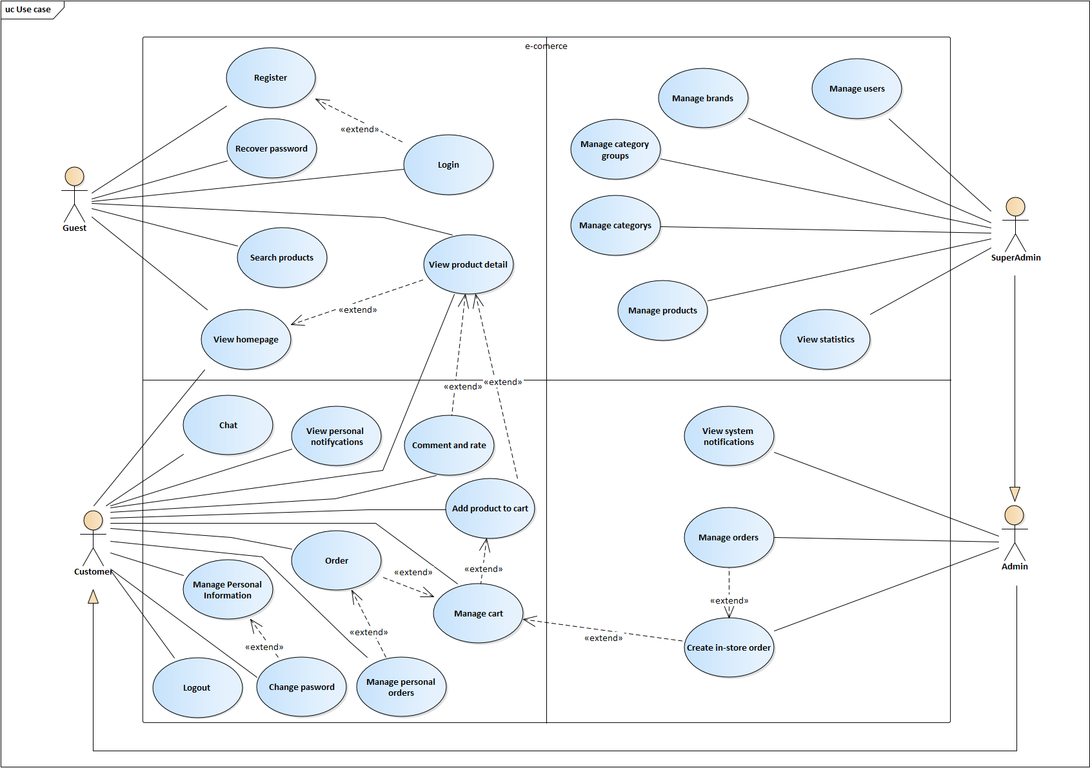

Image 3.1. Use case diagram

## USE CASE SPECIFICATION

### Recover password

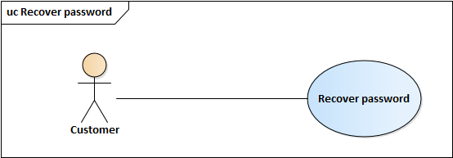

Image 3.2. Use case Recover password

Table 3.3. Specific description Recovery password

|  |  |
| --- | --- |
| Use Case ID | UC_5 |
| Name | Forget password |
| Goal | Allows users to reset their account password |
| Actors | Customer |
| Pre-conditions | Have a website account |
| Main flow | 1. On the login page 2. Click “Quên mật khẩu” 3. Enter your email and click “Tạo mật khẩu mới” on new page appears 4. An email will send to your email within a new password 5. Enter your PIN code into the new page and enter your new account password 6. Click “Đặt lại mật khẩu” |

### Manage personal information

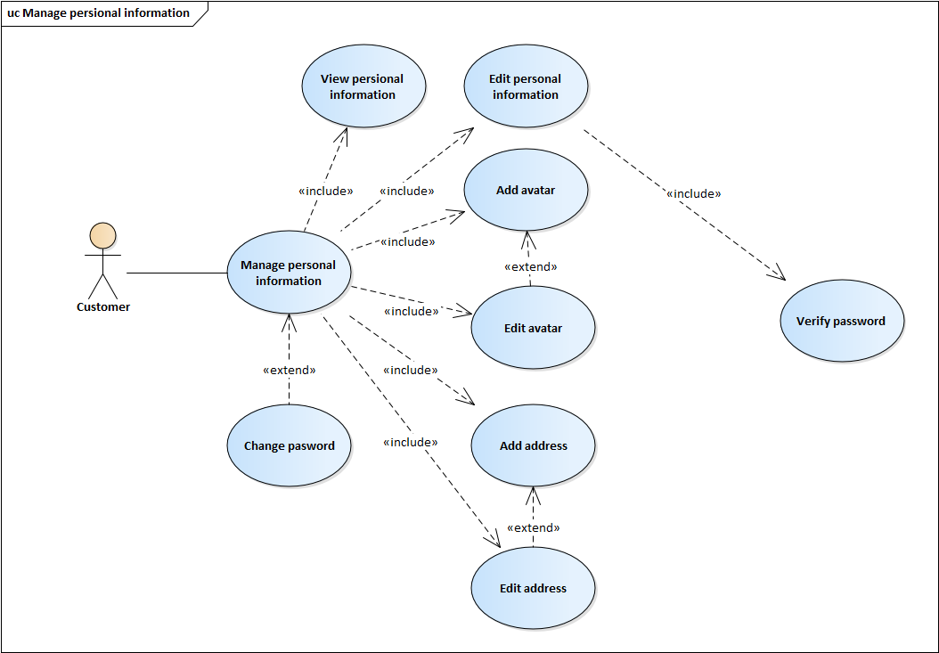

Image 3.3. Use case Manage personal information

#### Add address

Table 3.4. Specific description Add address

|  |  |
| --- | --- |
| Use Case ID | UC_6.5 |
| Name | Add address |
| Goal | Allows users to add their address |
| Actors | Customer |
| Pre-conditions | Signed in to the website |
| Main flow | 1. On any page of website after logged in, click on your name on header bar, you will be moved to Personal information page 2. Click “Địa chỉ” on navigation bar to move to address page 3. Click “Thêm địa chỉ” 4. On the new dialog appears, enter your address and then click “Lưu” |

#### Edit address

Table 3.5. Specific description Edit address

|  |  |
| --- | --- |
| Use Case ID | UC_6.6 |
| Name | Add address |
| Goal | Allows users to edit their addresses |
| Actors | Customer |
| Pre-conditions | Signed in to the website |
| Main flow | 1. On any page of website after logged in, click on your name on header bar, you will be moved to Personal information page 2. Click “Địa chỉ” on navigation bar to move to address page 3. Click on address item which you want to edit 4. On the new dialog appears, edit your address and then click “Lưu” |

### Add product to cart

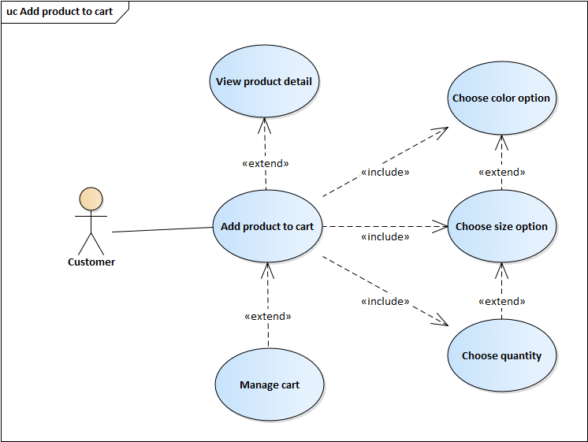

Image 3.4. Use case Add product to cart

Table 3.6. Specific description Add product to cart

|  |  |
| --- | --- |
| Use Case ID | UC_13 |
| Name | Add product to cart |
| Goal | Allows users to add products to cart |
| Actors | Customer |
| Pre-conditions | Signed in to the website and the product is added to the cart has enough quantity in stock and no quantity in the cart is less than 5 |
| Main flow | 1. Access the product detail page 2. Choose product color option 3. Choose product size option 4. Choose product quantity 5. Click “Thêm vào giỏ hàng” to add product to cart or click “Mua hàng” to add product to cart and move to cart page. The product |

### Manage cart

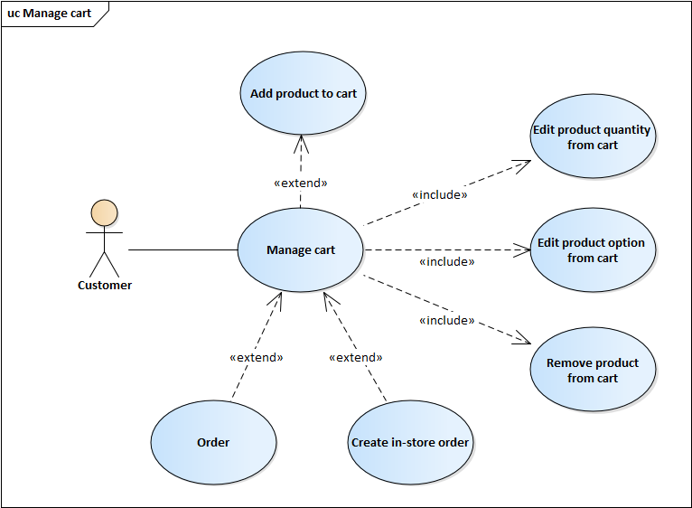

Image 3.5. Use case Manage cart

#### Edit product quantity from cart

Table 3.7. Specific description Edit product quantity from cart

|  |  |
| --- | --- |
| Use Case ID | UC_14.1 |
| Name | Edit product quantity from cart |
| Goal | Allows users to edit product quantity from cart |
| Actors | Customer |
| Pre-conditions | Signed in to the website and the product being manipulated has enough quantity in stock and no quantity in cart is less than 5 |
| Main flow | 1. Access to the cart page 2. On each cart item, click “+”, “-” or change number of quantity field to change product quantity |

#### Edit product option from cart

Table 3.8. Specific description Edit product option from cart

|  |  |
| --- | --- |
| Use Case ID | UC_14.2 |
| Name | Edit product option from cart |
| Goal | Allows users to edit product option from cart |
| Actors | Customer |
| Pre-conditions | Signed in to the website and the product being manipulated has enough quantity in stock and no quantity in cart is less than 5 |
| Main flow | 1. Access to the cart page 2. Click on option field below one cart item which you want to change option 3. Choose your option in new form 4. Click “Thay đổi” to change option of cart item |

#### Remove product from cart

Table 3.9. Specific description Remove product from cart

|  |  |
| --- | --- |
| Use Case ID | UC_14.3 |
| Name | Remove product from cart |
| Goal | Allows users to remove product from cart |
| Actors | Customer |
| Pre-conditions | Signed in to the website |
| Main flow | 1. Access to the cart page 2. Click remove icon in one cart item that you want to remove 3. A confirm dialog appears, click “Xóa” to remove cart item |

### Order

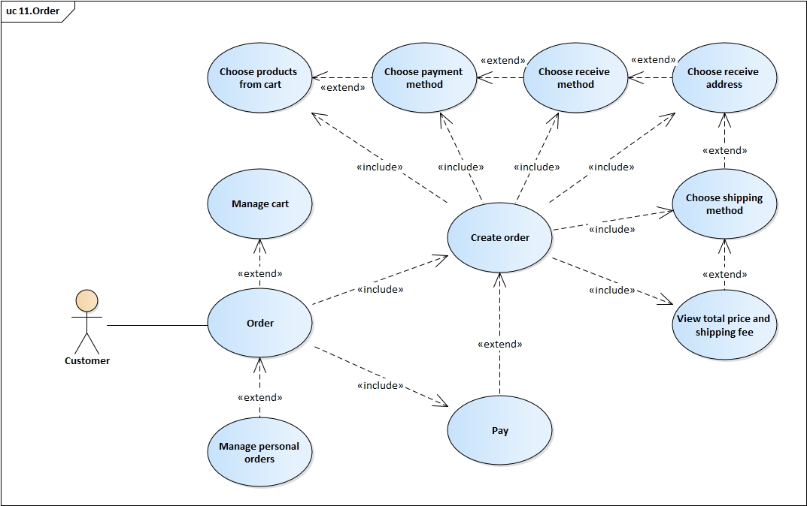

Image 3.6. Use cart order

#### Create order

Table 3.10. Specific description Create order

|  |  |
| --- | --- |
| Use Case ID | UC_15.1 |
| Name | Create order |
| Goal | Allows users to create order |
| Actors | Customer |
| Pre-conditions | Signed in to the website |
| Main flow | 1. Access to the cart page 2. Choose products that you want to order 3. Click “Mua hàng”, you will be moved to Create order page 4. Your order method is “Đặt hàng online” 5. Choose your payment method in “Phương thức thanh toán” field 6. Choose your receive method in “Phương thức nhận hàng” field 7. Choose your receive address in “Chọn địa chỉ” 8. Choose your shipping method in “Giao hàng” field 9. Shipping fee and total price is shown 10. Click “Đặt hàng” to create order |

#### Pay

Table 3.11. Specific description Pay

|  |  |
| --- | --- |
| Use Case ID | UC_15.2 |
| Name | Pay |
| Goal | Allows users to pay the order |
| Actors | Customer |
| Pre-conditions | Signed in to the website, order pending pay |
| Main flow | 1. Click “Thanh toán” in order detail page, you will be moved to pay page 2. In pay page, follow the instructions to pay 3. After finished, you will be returned to order detail page |

### Manage personal orders

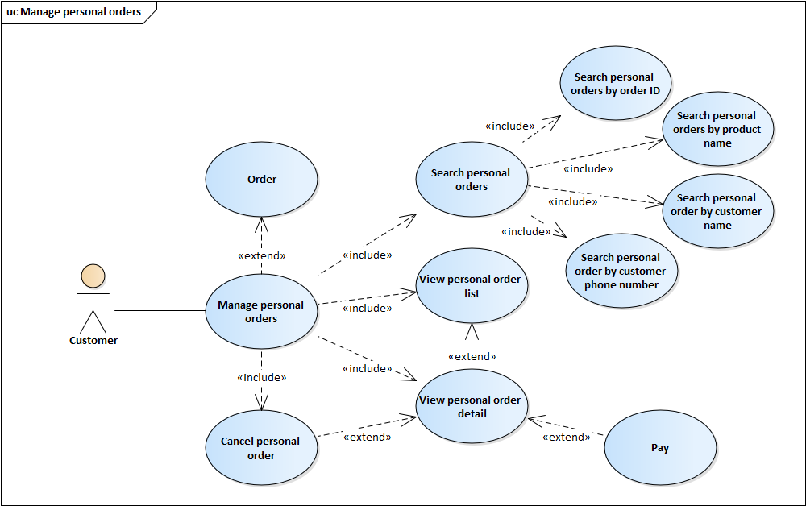

Image 3.7. Use case Manage personal orders

#### View personal order detail

Table 3.12. Specific description View personal order detail

|  |  |
| --- | --- |
| Use Case ID | UC_16.3 |
| Name | View personal order detail |
| Goal | Allows users to search their orders by date |
| Actors | Customer |
| Pre-conditions | Signed in to the website |
| Main flow | 1. Access to Customer’s order management page 2. Choose one order in order list that you want to view detail 3. Order detail will be shown in new page (Personal order detail page) |

#### Cancel personal order

Table 3.13. Specific description Cancel personal order

|  |  |
| --- | --- |
| Use Case ID | UC_16.4 |
| Name | Cancel personal order |
| Goal | Allows users to cancel their orders |
| Actors | Customer |
| Pre-conditions | Signed in to the website, order have “Chờ xử lý” status |
| Main flow | 1. Access to Personal order detail page 2. Choose “Hủy đơn hàng” 3. New confirm dialog appear, choose your reason 4. Click “Hủy đơn hàng” to cancel order |

### View system notifications

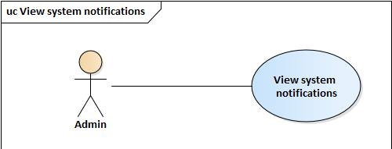

Image 3.8. Use case View system notifications

Table 3.14. Specific description View system notifications

|  |  |
| --- | --- |
| Use Case ID | UC_17 |
| Name | View system notifications |
| Goal | Allows users with Admin role or SuperAdmin role to view systems notifications |
| Actors | Admin, SuperAdmin |
| Pre-conditions | Signed in to the website with Admin role or SuperAdmin role |
| Main flow | 1. Personal notifications are shown in top navigation bar |

### Manage users

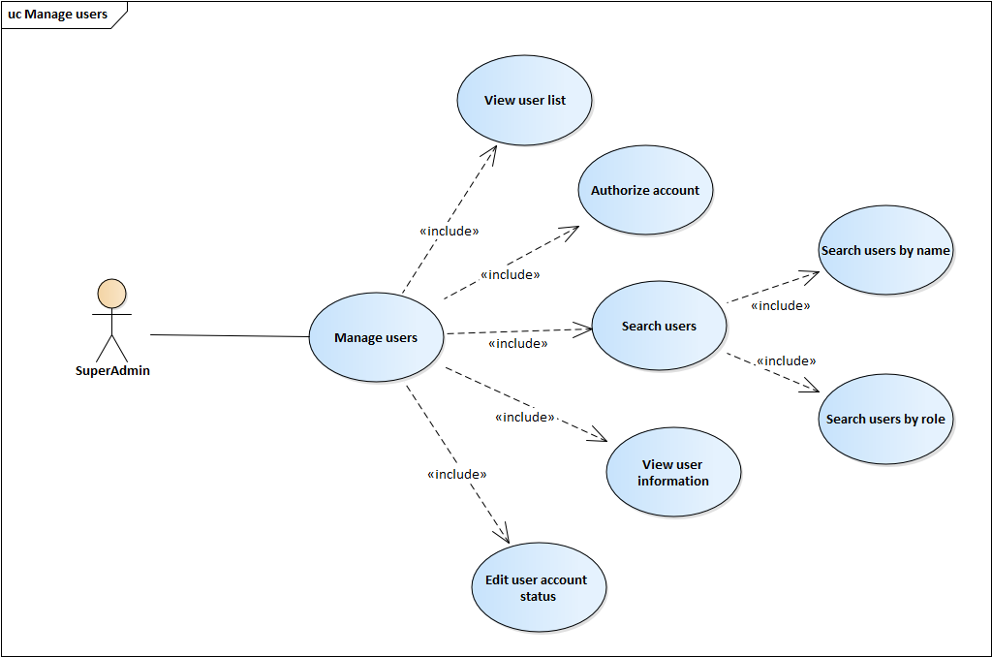

Image 3.9. Use case Manage users

#### View user information

Table 3.15. Specific description View user information

|  |  |
| --- | --- |
| Use Case ID | UC_18.3 |
| Name | View user information |
| Goal | Allows users with SuperAdmin role to view user information |
| Actors | SuperAdmin |
| Pre-conditions | Signed in to the website with SuperAdmin role |
| Main flow | 1. Access to user management page 2. Click on one user of user list that you want to view information 3. Selected user information is shown in new page (User information page) |

#### Authorize account

Table 3.16. Specific description Authorize account

|  |  |
| --- | --- |
| Use Case ID | UC_18.4 |
| Name | View user information |
| Goal | Allows users with SuperAdmin role to authorize account |
| Actors | SuperAdmin |
| Pre-conditions | Signed in to the website with SuperAdmin role |
| Main flow | 1. Access to user information page 2. Choose role in field “Quyền hạn” 3. Click “Xác nhận” to authorize |

#### Edit user account status

Table 3.17. Specific description Edit usser account status

|  |  |
| --- | --- |
| Use Case ID | UC_18.5 |
| Name | Edit user account status |
| Goal | Allows users with SuperAdmin role to edit user account status |
| Actors | SuperAdmin |
| Pre-conditions | Signed in to the website with SuperAdmin role |
| Main flow | 1. Access to user information page 2. Choose status in field “Trạng thái” 3. Click “Xác nhận” to change status |

### Manage products

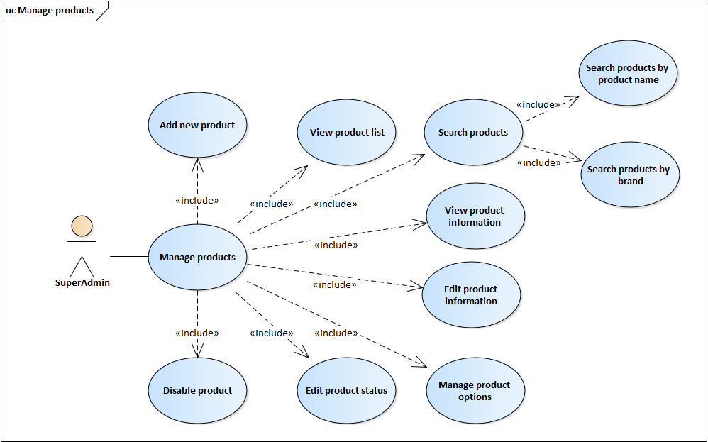

Image 3.10. Use case Manage products

#### Add new product

Table 3.18. Specific description Add new product

|  |  |
| --- | --- |
| Use Case ID | UC_22.1 |
| Name | Add new product |
| Goal | Allows users with SuperAdmin role to add new product |
| Actors | SuperAdmin |
| Pre-conditions | Signed in to the website with SuperAdmin role |
| Main flow | 1. Access to products management page 2. Click “Thêm sản phẩm mới” 3. On the new page appears, enter new product information then click “Tạo” |

#### Edit product information

Table 3.19. Specific description Edit product information

|  |  |
| --- | --- |
| Use Case ID | UC_22.5 |
| Name | Edit product information |
| Goal | Allows users with SuperAdmin role to edit product information |
| Actors | SuperAdmin |
| Pre-conditions | Signed in to the website with SuperAdmin role |
| Main flow | 1. Access to product information page 2. Click “Sửa thông tin” 3. On the new form appears, edit product information 4. Click “Lưu” to save change |

#### Manage product options

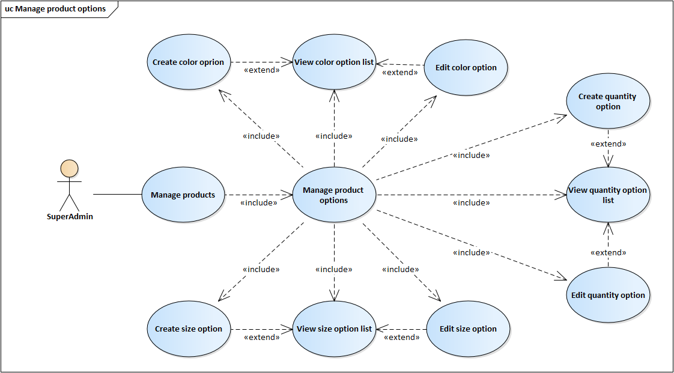

Image 3.11. Use case Manage product options

##### Create color option

Table 3.20. Specific description Add color option

|  |  |
| --- | --- |
| Use Case ID | UC_22.6.1 |
| Name | Create color option |
| Goal | Allows users with SuperAdmin role to add product color option |
| Actors | SuperAdmin |
| Pre-conditions | Signed in to the website with SuperAdmin role |
| Main flow | 1. Access to product options management page 2. Click “Thêm” on “Màu sản phẩm” region 3. On the new form appears, fill color information 4. Click save icon to create color option |

##### Edit color option

Table 3.21. Specific description Edit color option

|  |  |
| --- | --- |
| Use Case ID | UC_22.6.3 |
| Name | Edit color option |
| Goal | Allows users with SuperAdmin role to edit product color option |
| Actors | SuperAdmin |
| Pre-conditions | Signed in to the website with SuperAdmin role |
| Main flow | 1. Access to product options management page 2. The product color option list show on “Màu sản phẩm” region 3. Click edit icon on one of product color option list that you want to edit 4. On the new form appears, edit color option information 5. Click save icon to save change |

##### Create size option

Table 3.22. Specific description Add size option

|  |  |
| --- | --- |
| Use Case ID | UC_22.6.4 |
| Name | Create config option |
| Goal | Allows users with SuperAdmin role to add product config option |
| Actors | SuperAdmin |
| Pre-conditions | Signed in to the website with SuperAdmin role |
| Main flow | 1. Access to product options management page 2. Click add icon on “Kích cỡ sản phẩm” region 3. On the new form appears, fill config infomation 4. Click save to create config option |

##### Edit size option

Table 3.23. Specific description Edit size option

|  |  |
| --- | --- |
| Use Case ID | UC_22.6.6 |
| Name | Edit config option |
| Goal | Allows users with SuperAdmin role to edit product config option |
| Actors | SuperAdmin |
| Pre-conditions | Signed in to the website with SuperAdmin role |
| Main flow | 1. Access to product options management page 2. The product config option list show on “Cấu hình sản phẩm” region 3. Click edit icon on one of product config option list that you want to edit 4. On the new form appears, edit config option information 5. Click save icon to save change |

##### Create quantity option

Table 3.24. Specific description Add quantity option

|  |  |
| --- | --- |
| Use Case ID | UC_22.6.7 |
| Name | Add price option |
| Goal | Allows users with SuperAdmin role to add product price option |
| Actors | SuperAdmin |
| Pre-conditions | Signed in to the website with SuperAdmin role |
| Main flow | 1. Access to product options management page 2. Click add icon on “Giá và số lượng sản phẩm” region 3. On the new form appears, fill price information 4. Click save icon to create price option |

##### Edit quantity option

Table 3.25. Specific description Edit quantity option

|  |  |
| --- | --- |
| Use Case ID | UC_22.6.9 |
| Name | Edit price option |
| Goal | Allows users with SuperAdmin role to edit product price option |
| Actors | SuperAdmin |
| Pre-conditions | Signed in to the website with SuperAdmin role |
| Main flow | 1. Access to product options management page 2. The product price option list show on “Số lượng sản phẩm” region 3. Click edit icon on one of product price option list that you want to edit 4. On the new form appears, edit quantity of product 5. Click save ion to save change |

### Manage orders

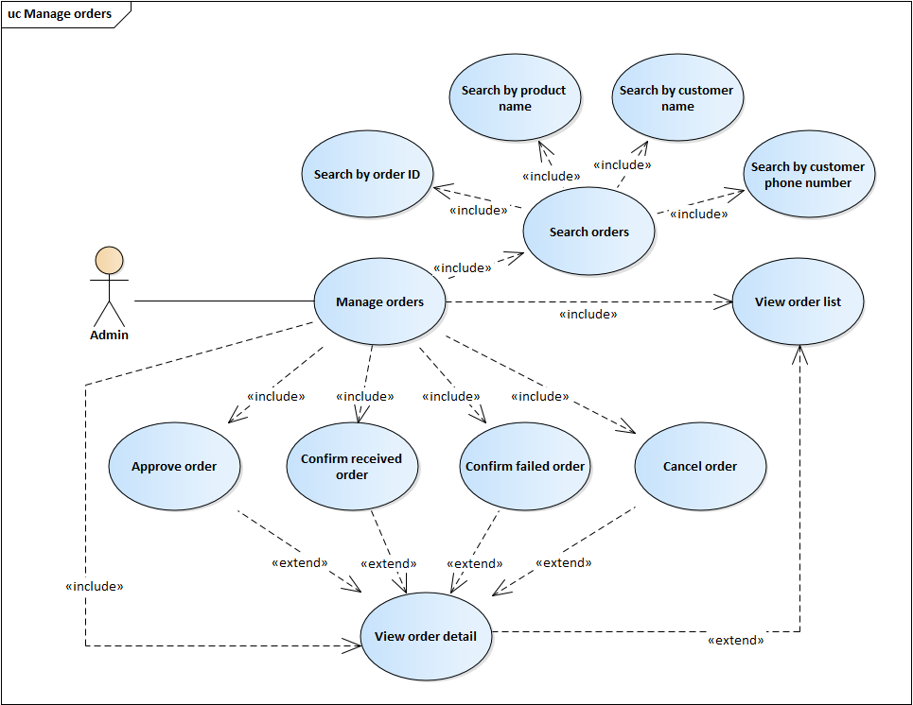

Image 3.12. Use case Manage orders

#### View order detail

Table 3.26. Specific description View order detail

|  |  |
| --- | --- |
| Use Case ID | UC_23.3 |
| Name | View order detail |
| Goal | Allows users with Admin role or SuperAdmin role to view order detail |
| Actors | Admin, SuperAdmin |
| Pre-conditions | Signed in to the website with Admin role or SuperAdmin role |
| Main flow | 1. Access to order management page 2. Choose one order in order list that you want to view detail 3. Details of the selected order will be shown in new page (Order detail page) |

#### Approve order

Table 3.27. Specific description Approve order

|  |  |
| --- | --- |
| Use Case ID | UC_23.4 |
| Name | Approve order |
| Goal | Allows users with Admin role or SuperAdmin role to Approve order |
| Actors | Admin, SuperAdmin |
| Pre-conditions | Signed in to the website with Admin role or SuperAdmin role, order have “Chờ xử lý” status |
| Main flow | 1. Access to Order detail page 2. Choose “Duyệt đơn hàng” to approve order |

#### Confirm received order

Table 3.28. Specific description Confirm received order

|  |  |
| --- | --- |
| Use Case ID | UC_23.5 |
| Name | Approve order |
| Goal | Allows users with Admin role or SuperAdmin role to confirm received order |
| Actors | Admin, SuperAdmin |
| Pre-conditions | Signed in to the website with Admin role or SuperAdmin role, order have “Đang giao hàng” status |
| Main flow | 1. Access to Order detail page 2. Choose “Xác nhận hoàn thành” to confirm received order |

#### Confirm failed order

Table 3.29. Specific description Confirm failed order

|  |  |
| --- | --- |
| Use Case ID | UC_23.6 |
| Name | Approve order |
| Goal | Allows users with Admin role or SuperAdmin role to confirm failed order |
| Actors | Admin, SuperAdmin |
| Pre-conditions | Signed in to the website with Admin role or SuperAdmin role, order have “Đang giao hàng” status |
| Main flow | 1. Access to Order detail page 2. Choose “Xác nhận thất bại” to confirm failed order |

#### Cancel order

Table 3.30. Specific description Cancel order

|  |  |
| --- | --- |
| Use Case ID | UC_23.7 |
| Name | Cancel order |
| Goal | Allows users with Admin role or SuperAdmin role to cancel order |
| Actors | Admin, SuperAdmin |
| Pre-conditions | Signed in to the website with Admin role or SuperAdmin role, order have “Chờ xử lý” status |
| Main flow | 1. Access to Order detail page 2. Choose “Hủy đơn hàng” 3. New confirm dialog appear, choose your reason 4. Click “Hủy đơn hàng” to cancel order |

### Create in-store order

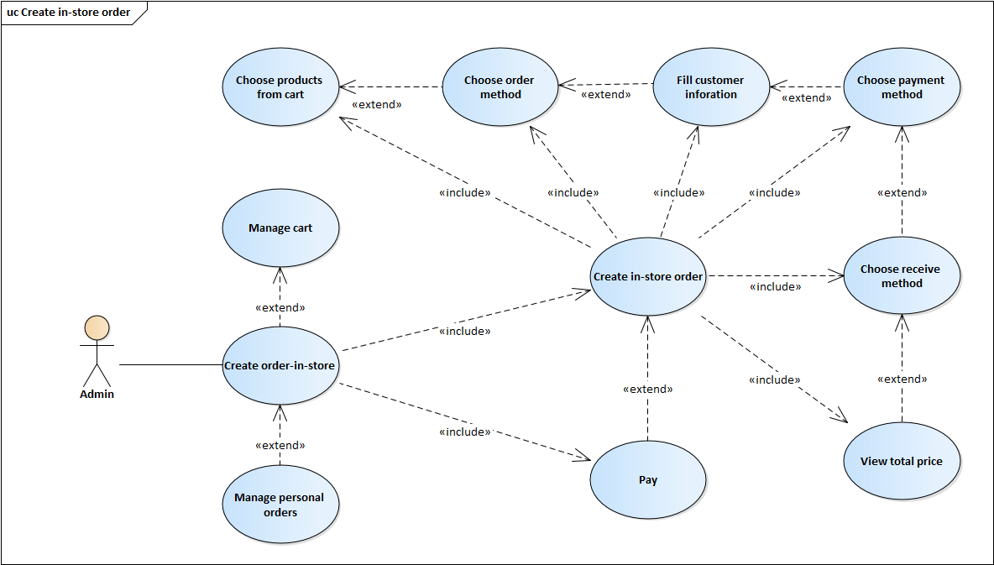

Image 3.13. Use case Create in-store order

#### Create in-store order

Table 3.31. Specific description Create in-store order

|  |  |
| --- | --- |
| Use Case ID | UC_24.1 |
| Name | Create in-store order |
| Goal | Allows users with Admin role or SuperAdmin role to create in-store order |
| Actors | Admin, SuperAdmin |
| Pre-conditions | Signed in to the website with Admin role or SuperAdmin role, order have “Chờ xử lý” status |
| Main flow | 1. Access to the cart page 2. Choose products that you want to order 3. Click “Mua hàng”, you will be moved to Create order page 4. Choose “Đặt hàng tại của hàng” in “Phương thức đặt hàng” field 5. Choose your payment method in “Phương thức thanh toán” field 6. Choose “Nhận hàng tại của hàng” in “Phương thức nhận hàng” field 7. Total price is shown 8. Click “Đặt hàng” to create in-store order |

# SOFTWARE DESIGN



## SYSTEM DESIGN



### Work flow

#### Online ordering

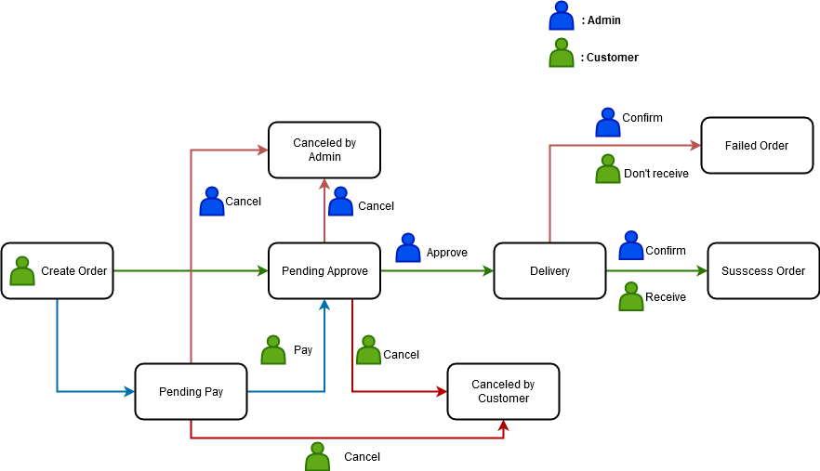

Image 4.1. Work flow about online order



#### Create order in store

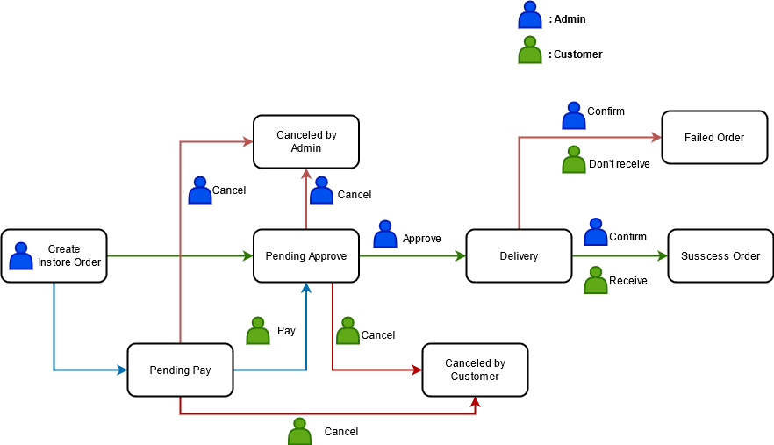

Image 4.2. Work flow about create order in store

### Sequence diagram

#### Login

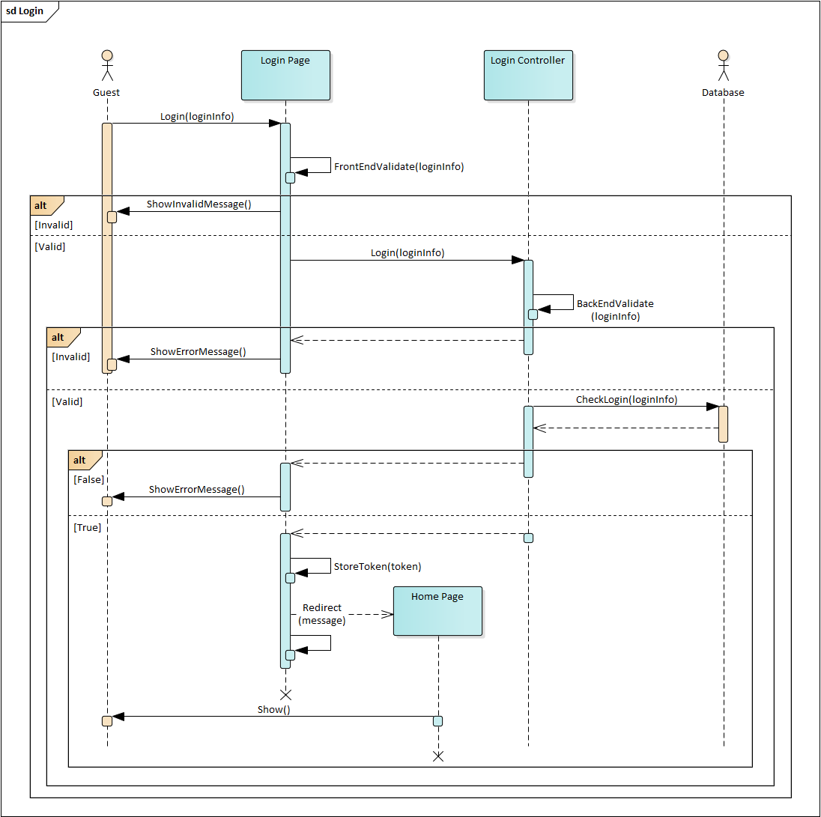

Image 4.3. Sequence diagram for Login

#### Recovery password

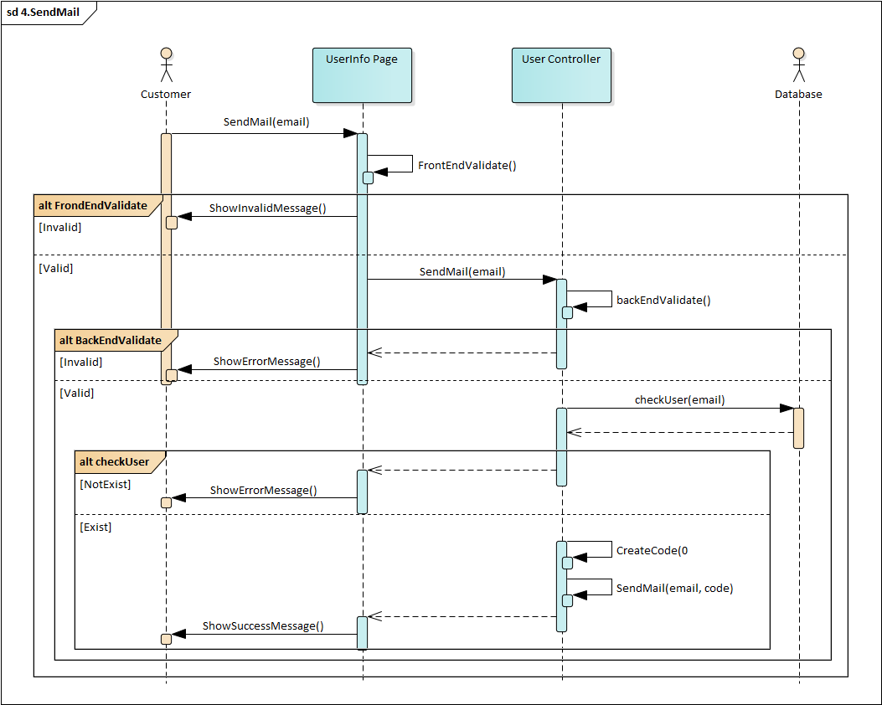

Image 4.4. Send mail

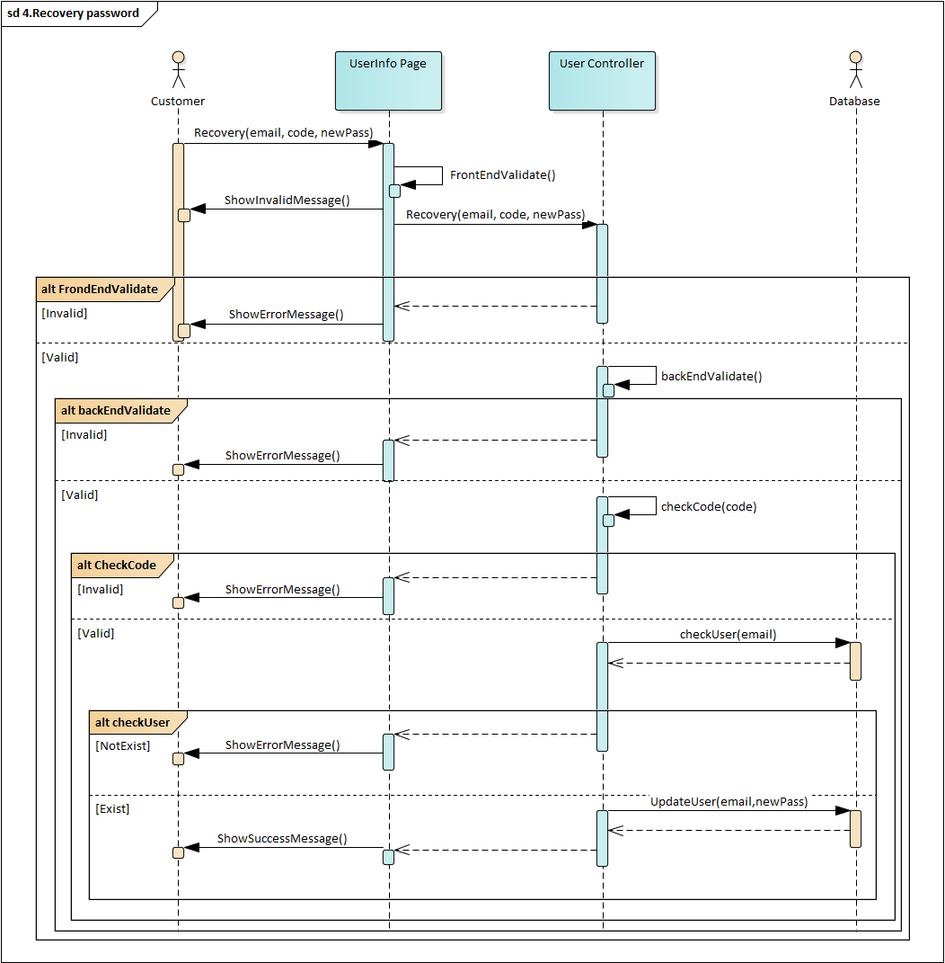

Image 4.5. Recovery password

#### Change password

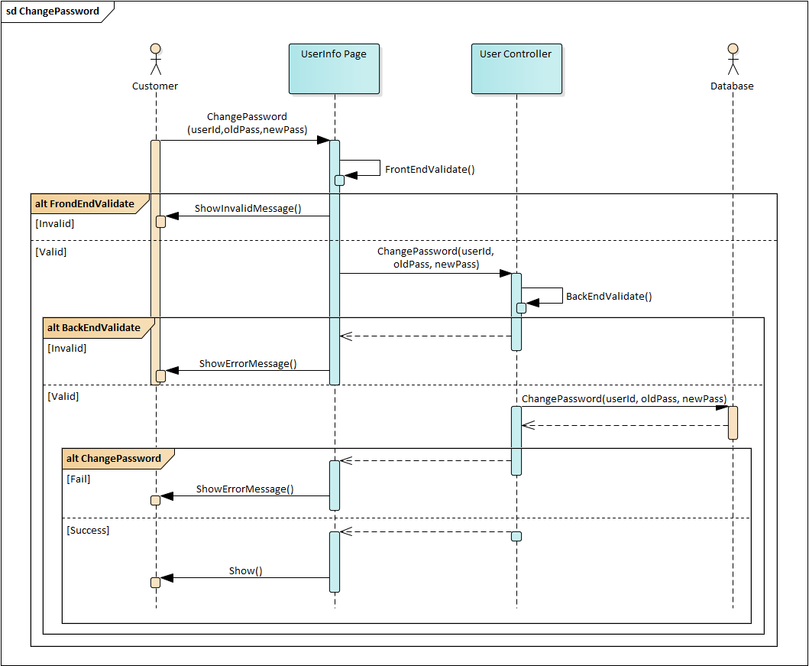

Image 4.6. Sequence diagram for Change password



#### Add product to cart

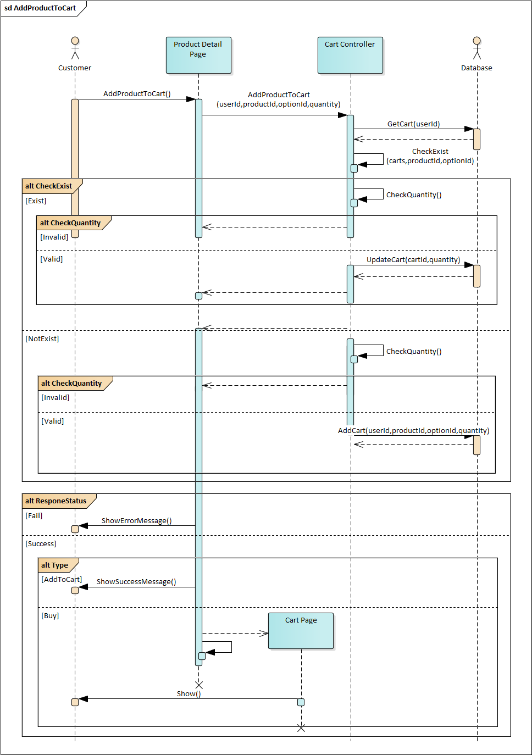

Image 4.7. Sequence diagram for Add product to cart

#### Create Order

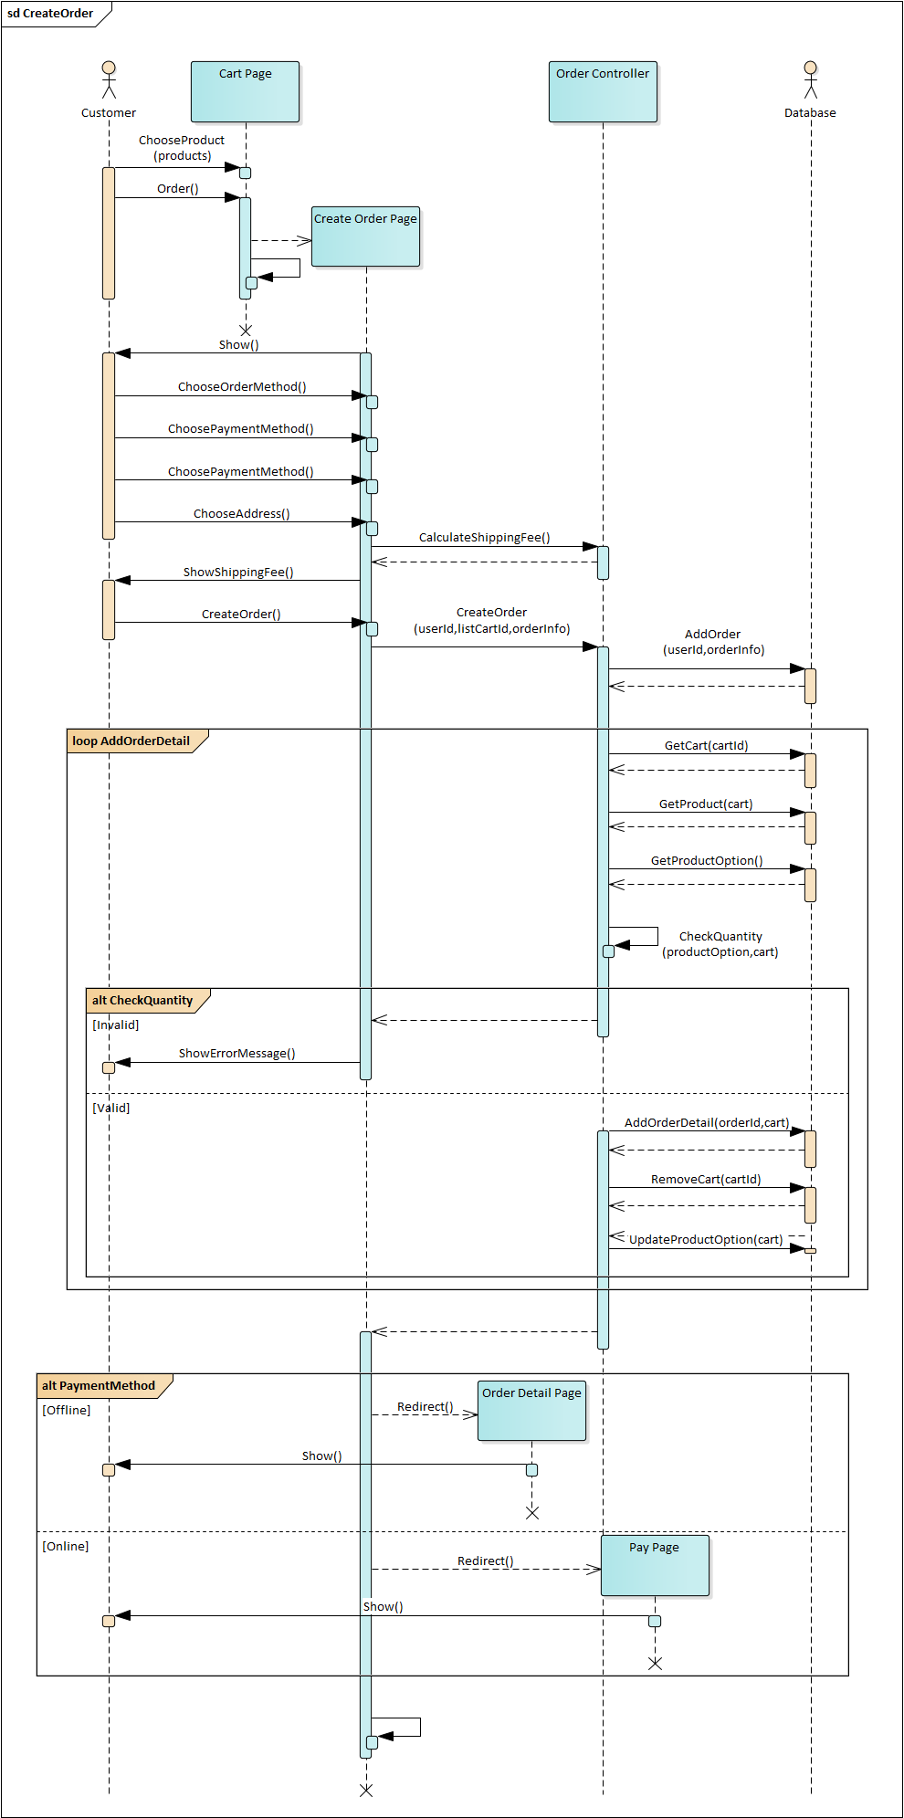

Image 4.8. Sequence diagram for Create order

#### Manage personal order

##### Cancel personal order

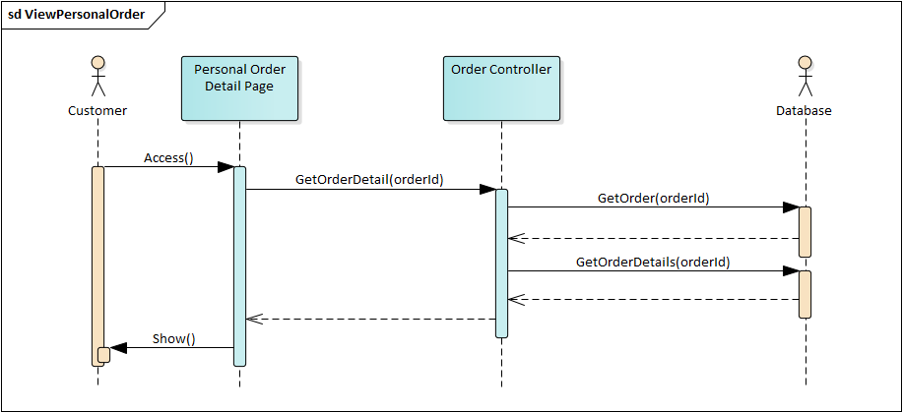

Image 4.9. Sequence diagram for Cancel personal order

#### Manage orders

##### Approve order

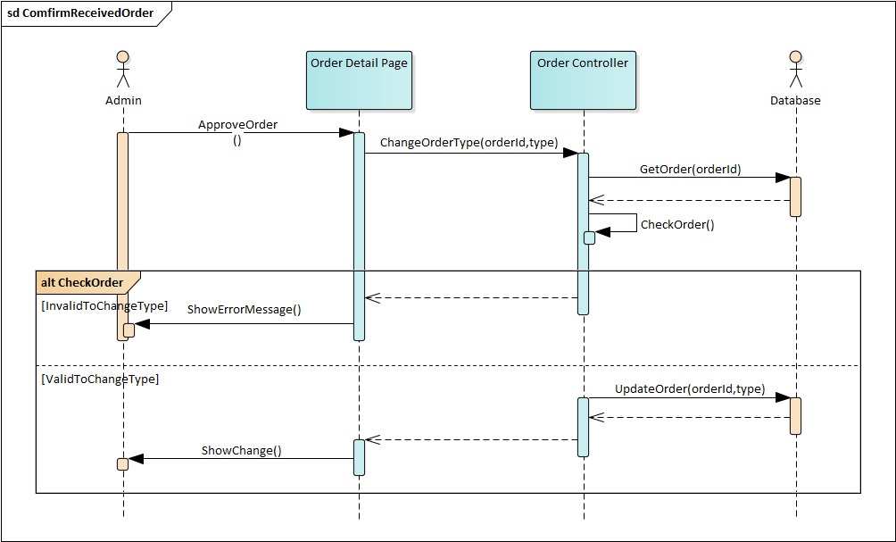

Image 4.10. Sequence diagram for Approve order

##### Confirm received order



Image 4.11. Sequence diagram for Confirm received order

##### Confirm failed order

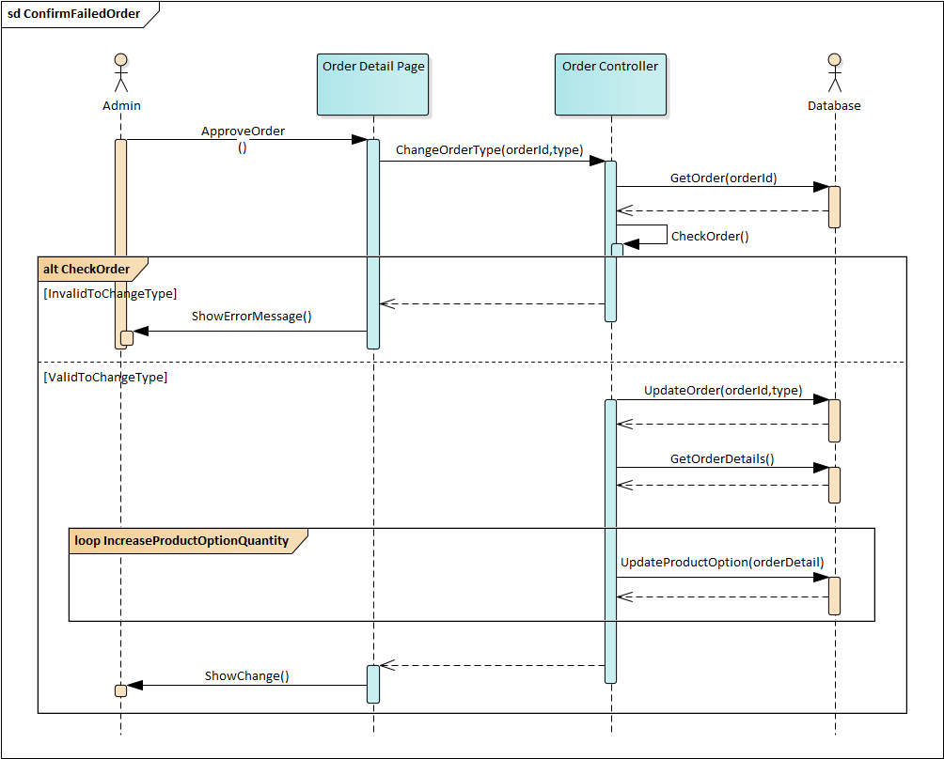

Image 4.12. Sequence diagram for Confirm failed order

#### Create instore order

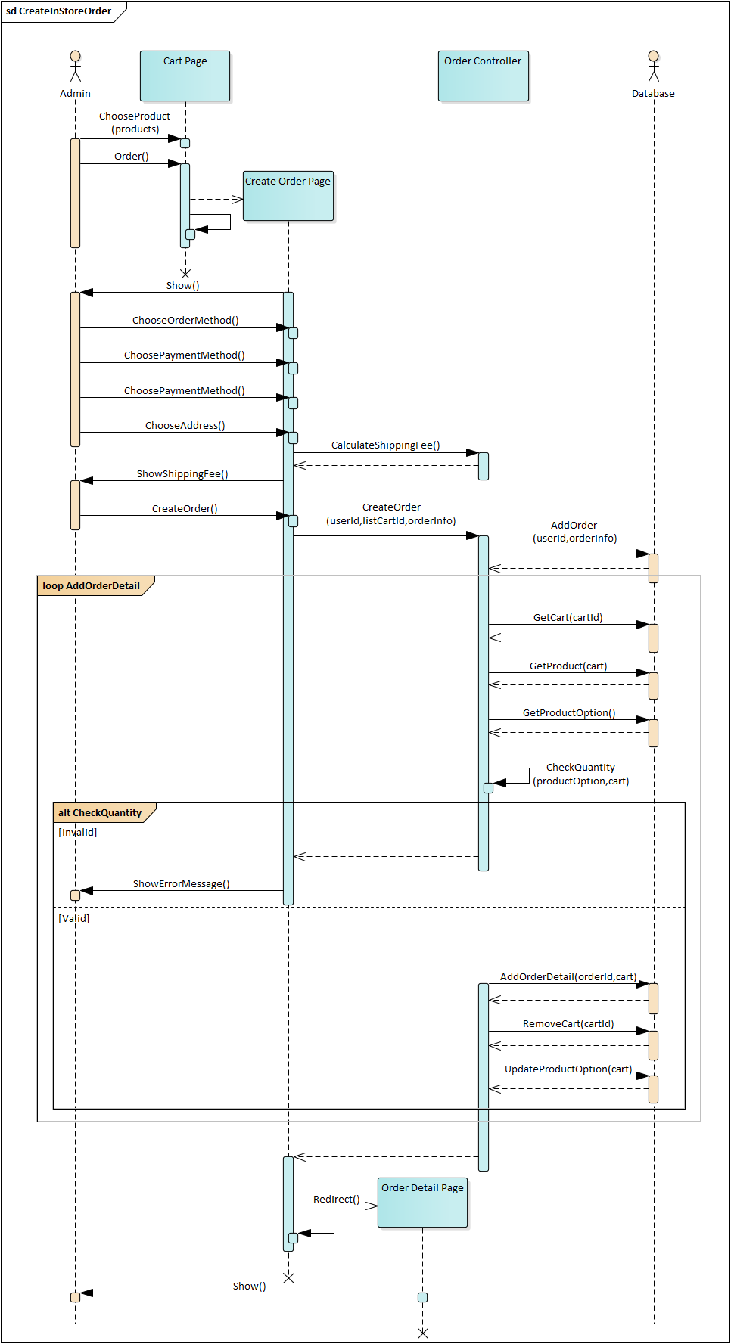

Image 4.13. Sequence diagram for Create in-store order



## DATABASE DESIGN

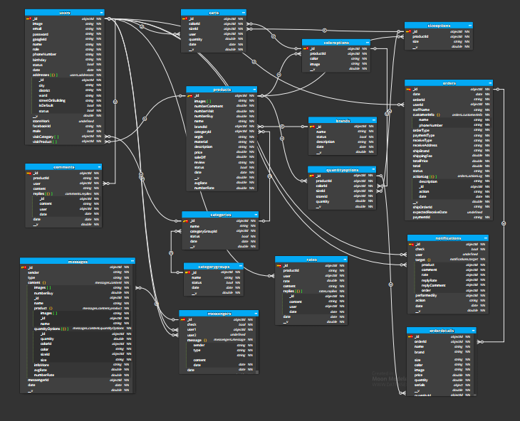

Image 4.14. Database diagram

### users

Table 4.1. users table

|  |  |  |  |  |  |
| --- | --- | --- | --- | --- | --- |
| Purpose: Save user account information | | | | | |
| No | **Column** | **Type** | **Key** | **Allow Null** | **Description** |
| 1 | _id | objectId | PK |  | Unique, auto generate |
| 2 | email | string |  |  | Unique |
| 3 | password | string |  |  |  |
| 4 | googleId | string |  | ✓ | Unique |
| 5 | facebookId | string |  | ✓ | Unique |
| 6 | name | string |  |  |  |
| 7 | role | string |  |  | Has 3 roles: “admin”, “superadmin”, “customer” |
| 8 | phoneNumber | string |  | ✓ |  |
| 9 | birthday | string |  | ✓ |  |
| 10 | image | string |  |  | user avatar |
| 11 | status | bool |  |  |  |
| 12 | date | date |  |  | Date create account |
| 13 | addresses | object |  | ✓ | The list of addresses each has a unique id used to identify |
| 14 | male | bool |  | ✓ | true is man, false is woman |
| 15 | visitCategory | Array objectId |  | ✓ | list of category the user visits |
| 16 | visitProduct | Array objectId |  | ✓ | list of product the user visits |

Table 4.2. addresses table

|  |  |  |  |  |  |
| --- | --- | --- | --- | --- | --- |
| Addresses is a child object in the users table | | | | | |
| Purpose: Save user account information | | | | | |
| No | **Column** | **Type** | **Key** | **Allow Null** | **Description** |
| 1 | id | objectId | PK |  | Unique, auto generate |
| 2 | city | string |  |  |  |
| 3 | district | string |  |  |  |
| 4 | ward | string |  |  |  |
| 5 | streetOrBuilding | string |  |  |  |
| 6 | isDefault | bool |  |  | True: is the default address, each user has a unique default address |
| 7 | status | bool |  |  |  |

### brands

Table 4.3. brands table

|  |  |  |  |  |  |
| --- | --- | --- | --- | --- | --- |
| Purpose: Save the brands and its description | | | | | |
| No | **Column** | **Type** | **Key** | **Allow Null** | **Description** |
| 1 | _id | objectId | PK |  | Unique, auto generate |
| 2 | name | string |  |  |  |
| 3 | status | string |  |  |  |
| 4 | description | string |  | ✓ |  |
| 5 | date | date |  |  | Date create brand |

### categoryGroups

Table 4.4. categoryGroups table

|  |  |  |  |  |  |
| --- | --- | --- | --- | --- | --- |
| Purpose: Save the categoryGroups | | | | | |
| No | **Column** | **Type** | **Key** | **Allow Null** | **Description** |
| 1 | _id | objectId | PK |  | Unique, auto generate |
| 2 | name | string |  |  |  |
| 3 | status | string |  |  |  |
| 4 | date | date |  |  | Date create categoryGroups |

### categories

Table 4.5. categories table

|  |  |  |  |  |  |
| --- | --- | --- | --- | --- | --- |
| Purpose: Save the categories | | | | | |
| No | **Column** | **Type** | **Key** | **Allow Null** | **Description** |
| 1 | _id | objectId | PK |  | Unique, auto generate |
| 2 | name | string |  |  |  |
| 3 | status | string |  |  |  |
| 4 | categoryGroupId | objectId |  |  | Category group code |
| 5 | date | date |  |  | Date create category |

### products

Table 4.6. products table

|  |  |  |  |  |  |
| --- | --- | --- | --- | --- | --- |
| Purpose: Save all product’s information | | | | | |
| No | **Column** | **Type** | **Key** | **Allow Null** | **Description** |
| 1 | _id | objectId | PK |  | Unique, auto generate |
| 2 | name | string |  |  |  |
| 3 | images | string[] |  |  |  |
| 4 | brandId | objectId | FK |  |  |
| 5 | categoryId | objectId |  |  |  |
| 6 | origin | string |  |  |  |
| 7 | material |  |  |  |  |
| 8 | description |  |  | ✓ | Product short description |
| 9 | price | double |  |  | The price of the product |
| 10 | saleOff | double |  |  |  |
| 11 | review | string |  | ✓ |  |
| 12 | status | bool |  |  |  |
| 13 | date | date |  |  | Date add this product |
| 14 | numberVisit | double |  | ✓ | The number of people viewed this product |
| 15 | avgRate | double |  | ✓ | Average score rated |
| 16 | numberRate | double |  | ✓ | The number of people rated this product |
| 17 | numberComment | double |  | ✓ | The number of people commented this product |
| 18 | numberBuy | double |  | ✓ | The number of people bought this product |

### sizeOptions

Table 4.7. sizeOptions table

|  |  |  |  |  |  |
| --- | --- | --- | --- | --- | --- |
| Purpose: Contains 1 product size | | | | | |
| No | **Column** | **Type** | **Key** | **Allow Null** | **Description** |
| 1 | _id | objectId | PK |  |  |
| 2 | productId | objectId | FK |  |  |
| 3 | size | string |  |  | Size of product |

### colorOptions

Table 4.8. colorOptions table

|  |  |  |  |  |  |
| --- | --- | --- | --- | --- | --- |
| Purpose: Contains color information for the product | | | | | |
| No | **Column** | **Type** | **Key** | **Allow Null** | **Description** |
| 1 | _id | objectId | PK |  |  |
| 2 | productId | objectId | FK |  |  |
| 3 | color | string |  |  | Color of product |
| 4 | image | string |  |  | Contain url image of product |

### quantityOption

Table 4.9. quantityOptions table

|  |  |  |  |  |  |
| --- | --- | --- | --- | --- | --- |
| Purpose: Contains quantity of 1 product corresponding to color and size | | | | | |
| No | **Column** | **Type** | **Key** | **Allow Null** | **Description** |
| 1 | _id | objectId | PK |  |  |
| 2 | productId | objectId | FK |  |  |
| 3 | colorId | objectId | FK |  |  |
| 4 | sizeId | objectId | FK |  |  |
| 7 | quantity | double |  |  | Number of product in stock |

### comments

Table 4.10. comments table

|  |  |  |  |  |  |
| --- | --- | --- | --- | --- | --- |
| Purpose: Save all comments | | | | | |
| No | **Column** | **Type** | **Key** | **Allow Null** | **Description** |
| 1 | _id | objectId | PK |  |  |
| 2 | productId | objectId | FK |  | Product code |
| 3 | user | objectId | FK |  | Commenter code |
| 4 | content | string |  |  |  |
| 5 | replies | object |  |  | Contains feedback |
| 6 | date | double |  |  | Date create comment |

Table 4.11. replies table

|  |  |  |  |  |  |
| --- | --- | --- | --- | --- | --- |
| replies is a child object in the comments table | | | | | |
| Purpose: Save Responses | | | | | |
| No | **Column** | **Type** | **Key** | **Allow Null** | **Description** |
| 1 | id | objectId | PK |  | Unique, auto generate |
| 2 | content | string |  |  |  |
| 3 | user | objectId | FK |  | Responder code |
| 4 | date | date |  |  | Date create reply |

### rates

Table 4.12. rates table

|  |  |  |  |  |  |
| --- | --- | --- | --- | --- | --- |
| Purpose: Save all rates | | | | | |
| No | **Column** | **Type** | **Key** | **Allow Null** | **Description** |
| 1 | _id | objectId | PK |  |  |
| 2 | productId | objectId | FK |  | Product code |
| 3 | user | objectId | FK |  | Reviewer code |
| 4 | rate | double |  |  | Score of review (greater than or equal to 1, less than or equal to 5) |
| 5 | content | string |  |  |  |
| 6 | replies | object |  |  | Contains feedback |
| 7 | date | double |  |  | Evaluation date |

Table 4.13. replies table

|  |  |  |  |  |  |
| --- | --- | --- | --- | --- | --- |
| replies is a child object in the rates table | | | | | |
| Purpose: Save Responses | | | | | |
| No | **Column** | **Type** | **Key** | **Allow Null** | **Description** |
| 1 | id | objectId | PK |  | Unique, auto generate |
| 2 | content | string |  |  |  |
| 3 | user | objectId | FK |  | Responder code |
| 4 | date | date |  |  | Date create reply |

### carts

Table 4.14. carts table

|  |  |  |  |  |  |
| --- | --- | --- | --- | --- | --- |
| Purpose: Save the user’s shopping cart information | | | | | |
| No | **Column** | **Type** | **Key** | **Allow Null** | **Description** |
| 1 | _id | objectId | PK |  |  |
| 2 | colorId | objectId | FK |  | colorOption code |
| 3 | sizeId | objectId | FK |  | sizeOption code |
| 4 | user | objectId | FK |  | Cart owner code |
| 5 | quantity | double |  |  |  |
| 6 | date | date |  |  | Date the product was added or updated to the cart |

### orders

Table 4.15. orders table

|  |  |  |  |  |  |
| --- | --- | --- | --- | --- | --- |
| Purpose: Save order information | | | | | |
| No | **Column** | **Type** | **Key** | **Allow Null** | **Description** |
| 1 | _id | objectId | PK |  | Unique, auto generate |
| 2 | orderId | string |  |  | Unique, order shorting code |
| 3 | userId | objectId | FK |  | Customer’s code order |
| 4 | staffName | string |  |  |  |
| 5 | customerInfo | object |  |  | Customer information |
| 6 | orderType | string |  |  |  |
| 7 | paymentType | string |  |  | Payment methods(online, pay on receipt) |
| 8 | reciveType | string |  |  | Recive modethods(at the store, delivery to address) |
| 9 | reciveAddress | string |  |  |  |
| 10 | shippingFee | double |  |  |  |
| 11 | totalPrice | double |  |  |  |
| 12 | total | double |  |  |  |
| 13 | status | string |  |  | Order status |
| 14 | actionLog | object |  |  |  |
| 15 | date | date |  |  | Date create order |
| 16 | shipOrdered | date |  |  | Delivery code |
| 17 | shipBrand |  |  |  | Delivery company code |
| 18 | expectedReceiveDate | date |  |  | Desired delivery date |
| 18 | paymentId | string |  |  | Payment code |

Table 4.16. customerInfo table

|  |  |  |  |  |  |
| --- | --- | --- | --- | --- | --- |
| customerInfo is a child object in the orders table | | | | | |
| Purpose: Save buyer infomation | | | | | |
| No | **Column** | **Type** | **Key** | **Allow Null** | **Description** |
| 1 | name | string |  |  |  |
| 2 | phoneNumber | string |  |  |  |

Table 4.17. actionLog table

|  |  |  |  |  |  |
| --- | --- | --- | --- | --- | --- |
| actionLog is a child object in the orders table | | | | | |
| Purpose: Save buyer information | | | | | |
| No | **Column** | **Type** | **Key** | **Allow Null** | **Description** |
| 1 | _id | objectId | PK |  | Unique, auto generate |
| 2 | action | string |  |  | Type of action |
| 3 | description | string |  |  |  |
| 4 | date | date |  |  | Execution date |

### orderDetail

Table 4.18. orderDetail tables

|  |  |  |  |  |  |
| --- | --- | --- | --- | --- | --- |
| Purpose: Save order detail | | | | | |
| No | **Column** | **Type** | **Key** | **Allow Null** | **Description** |
| 1 | _id | objectId | PK |  | Unique, auto generate |
| 2 | orderId | objectId | FK |  | Order code |
| 3 | name | string |  |  |  |
| 4 | brand | string |  |  |  |
| 5 | size | string |  |  |  |
| 6 | color | string |  |  |  |
| 7 | image | string |  |  |  |
| 8 | price | string |  |  |  |
| 9 | quantity | string |  |  |  |
| 10 | quantityId | object |  |  | quantityOption code |

### notifications

Table 4.19. notifications table

|  |  |  |  |  |  |
| --- | --- | --- | --- | --- | --- |
| Purpose: Save notifications | | | | | |
| No | **Column** | **Type** | **Key** | **Allow Null** | **Description** |
| 1 | _id | objectId | PK |  | Unique, auto generate |
| 2 | check | bool |  |  | Has seen is or not |
| 3 | user | objectId | FK |  | Notification recipients |
| 4 | target | object |  |  | Code of related information |
| 5 | performedBy | objectId |  |  | The person performing |
| 6 | action | string |  |  | Type of notice |
| 7 | date | date |  |  | Date of creation of the notice |

Table 4.20. target table

|  |  |  |  |  |  |
| --- | --- | --- | --- | --- | --- |
| target is a child object in the notifications table | | | | | |
| Purpose: Code of related information | | | | | |
| No | **Column** | **Type** | **Key** | **Allow Null** | **Description** |
| 1 | order | objectId | FK | ✓ | Code orders |
| 2 | product | objectId | FK | ✓ | Code products |
| 3 | rate | objectId | FK | ✓ | Code rates |
| 4 | replyRate | objectId | FK | ✓ | Code reply of rates |
| 5 | comment | objectId | FK | ✓ | Code comments |
| 6 | replyComment | objectId | FK | ✓ | Code reply of comments |

### Messenger

Table 4.21. messenger table

|  |  |  |  |  |  |
| --- | --- | --- | --- | --- | --- |
| Purpose: Used to save a use to save the content message | | | | | |
| No | **Column** | **Type** | **Key** | **Allow Null** | **Description** |
| 1 | _id | objectId | PK |  | Unique, auto generate |
| 2 | user1 | objectId | FK |  | Message sender code or message recipient code |
| 3 | user2 | objectId | FK |  | Message sender code or message recipient code |
| 4 | message | object |  |  | Content of message |
| 5 | check | bool |  |  | Used to check if the message has been viewed or not |
| 7 | date | date |  |  | Message sending time will update every time a new message is sent |

Table 4.22. messenger table

|  |  |  |  |  |  |
| --- | --- | --- | --- | --- | --- |
| message is a child object in the messenger table | | | | | |
| Purpose: Code of related information | | | | | |
| No | **Column** | **Type** | **Key** | **Allow Null** | **Description** |
| 1 | sender | objectId | FK | ✓ | The content of sender is user1 or user2 |
| 2 | type | objectId | FK | ✓ | Type message |
| 3 | content | objectId | FK | ✓ |  |
| 4 | date | objectId | FK | ✓ | Date send |

### Messages

Table 4.23. messenger table

|  |  |  |  |  |  |
| --- | --- | --- | --- | --- | --- |
| Purpose: Use to save the content message | | | | | |
| No | **Column** | **Type** | **Key** | **Allow Null** | **Description** |
| 1 | _id | objectId | PK |  | Unique, auto generate |
| 1 | sender | objectId | FK | ✓ | The content of sender is user1 or user2 |
| 2 | type | objectId | FK | ✓ | Type message |
| 3 | content | objectId | FK | ✓ |  |
| 4 | ‘date | objectId | FK | ✓ | Date send |

## INTERFACE DESIGN

### List of screens and screen flow on website

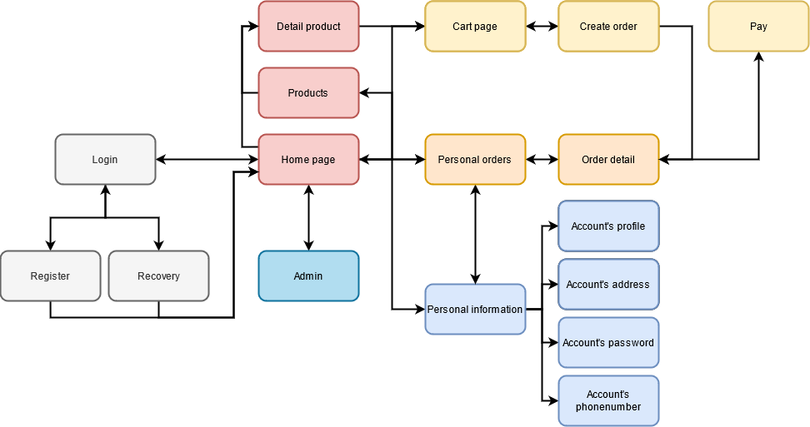

Image 4.15. Screen flow of Customer on website

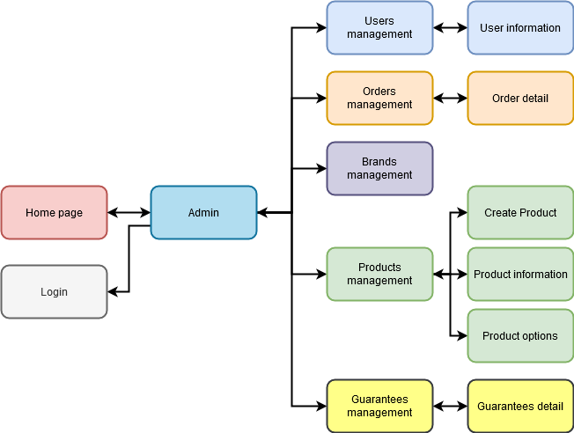

Image 4.16. Screen flow of Admin on website

### Screen details on website

#### Customer pages

##### Home page

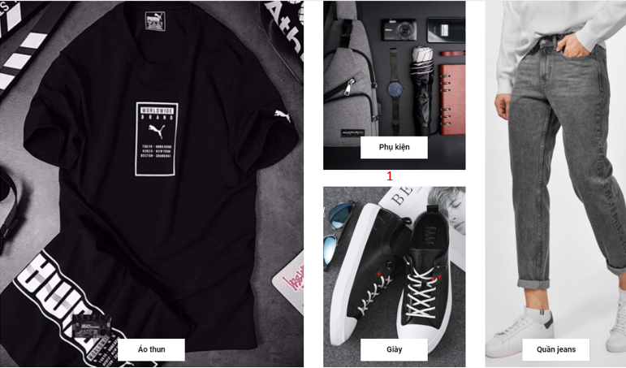

Image 4.17 Home screen

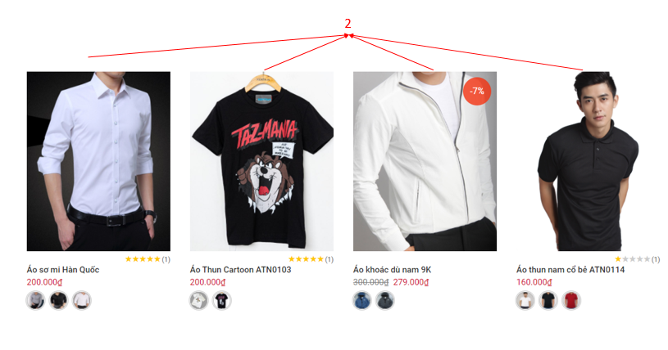

Image 4.18. Home page

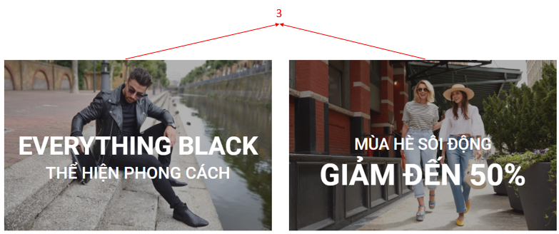

Image 4.19. Home page

Table 4.24. Describe Home page

|  |  |  |
| --- | --- | --- |
| **Index** | **Type** | **Meaning** |
| 1 | Link | Link used to show all category of products can go to product page filtered by that product type. |
| 2 | Link | Link used to show important information of product and can go to detail product page. |
| 3 | Link | Link used to go to product page filtered by condition. |

##### Product page filter by condition

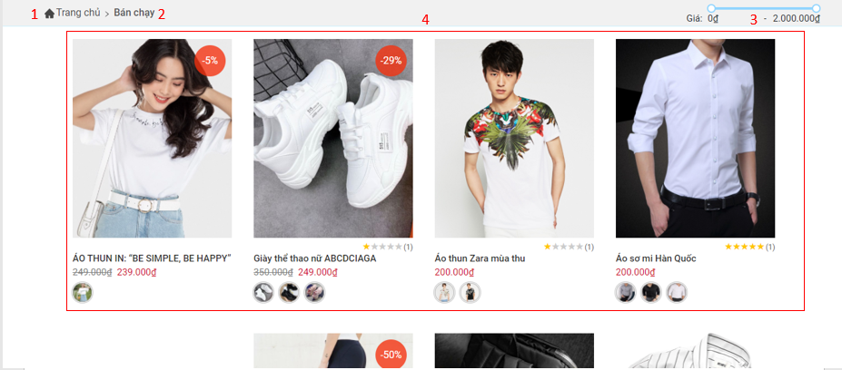

Image 4.20. Home page

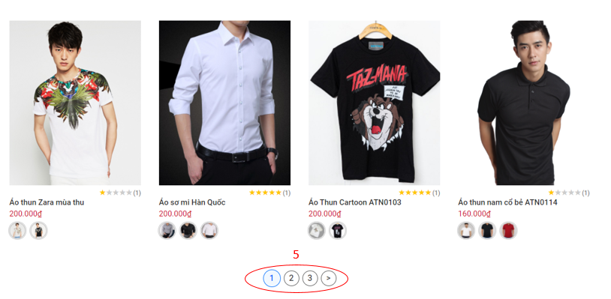

Image 4.21. Product page

Table 4.25. Describe Home page

|  |  |  |
| --- | --- | --- |
| **Index** | **Type** | **Meaning** |
| 1 | Link | Link used to go to home page. |
| 2 | Link | Show current condition. |
| 3 | Link | Filter product by price. |
| 4 | Link | Link used to show important information of product and can go to detail product page. |
| 5 | Link | Paging |

##### Detail product page

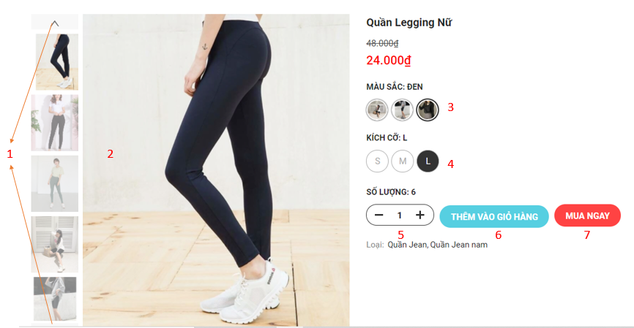

Image 4.22. Detail product page

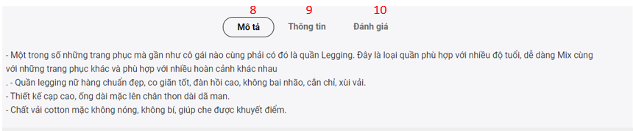

Image 4.23. More information of product detail page

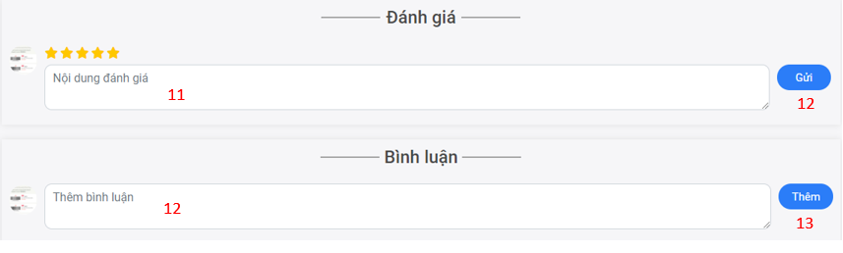

Image 4.24. Comment and race

Table 4.26. Describe Detail product page

|  |  |  |
| --- | --- | --- |
| **Index** | **Type** | **Meaning** |
| 1 | Button | View more image of product |
| 2 | Image | List image of product |
| 3 | Button | Choose color of product |
| 4 | Button | Choose size of product |
| 5 | Button | Change product quantity |
| 6 | Button | Add product to cart |
| 7 | Radio | Buy product |
| 8 | Button | View description of product |
| 9 | Button | View more information of product |
| 10 | Button | Go to comment and review function |
| 11 | Input | Type content rate |
| 12 | Button | Add new rate |
| 13 | Input | Type content comment |
| 14 | Button | Add new comment |

##### The Header of the customer page when not logged in



Image 4.25. Header of customer page when not logged in

Table 4.27. Describe Header of customer page when not logged in

|  |  |  |
| --- | --- | --- |
| **Index** | **Type** | **Meaning** |
| 1 | Drop down button | Menu used to view a list of product categories |
| 2 | Link | Link to home page |
| 3 | Link | View the best selling products |
| 4 | Link | See new product |
| 5 | Link | See featured products |
| 6 | Link | Go to login page |



##### The Header of the customer page when logged in



Image 4.26. Header of customer page when logged in

Table 4.28. Describe Header of customer page when logged in

|  |  |  |
| --- | --- | --- |
| **Index** | **Type** | **Meaning** |
| 1 | Link | Link go to manage page if you admin |
| 2 | Link | Open input to search |
| 3 | Link | Link go to cart page |
| 4 | Link | View messenger |
| 5 | Link | View notification |
| 6 | Link | Link go to profile page |

##### Login Page

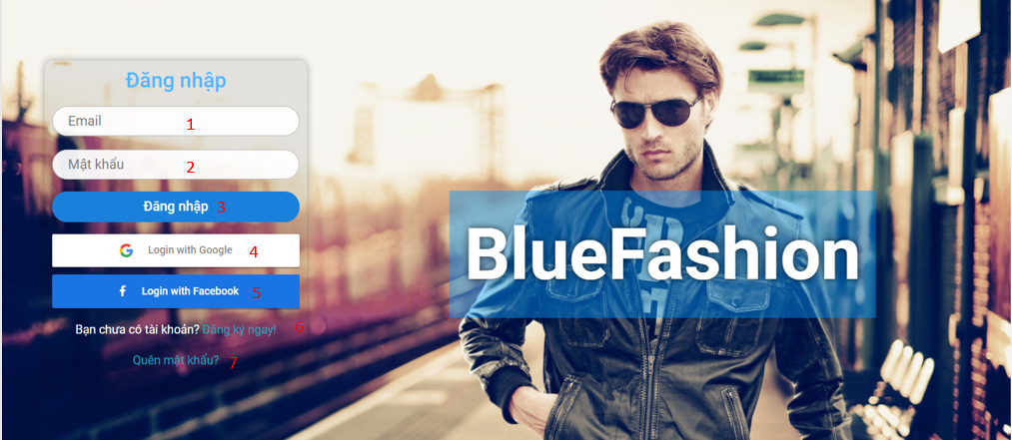

Image 4.27. Login page

Table 4.29. Describe Login page

|  |  |  |
| --- | --- | --- |
| **Index** | **Type** | **Meaning** |
| 1 | Input | Used to enter the Email |
| 2 | Input | Used to enter the Password |
| 3 | Button | Login with account |
| 4 | Button | Login with Google |
| 5 | Button | Login with Facebook |
| 6 | Link | Link to sign up for an account website |
| 7 | Link | Link forgotten password |

##### Forgot password Page



Image 4.28. Forgot password page

Table 4.30. Describe forgot password page

|  |  |  |
| --- | --- | --- |
| **Index** | **Type** | **Meaning** |
| 1 | Input | Used to enter the registered email account |
| 2 | Link | Go to login page |
| 2 | Button | Click to confirm |
| 3 | Link | Go to register page |

##### Registration Page

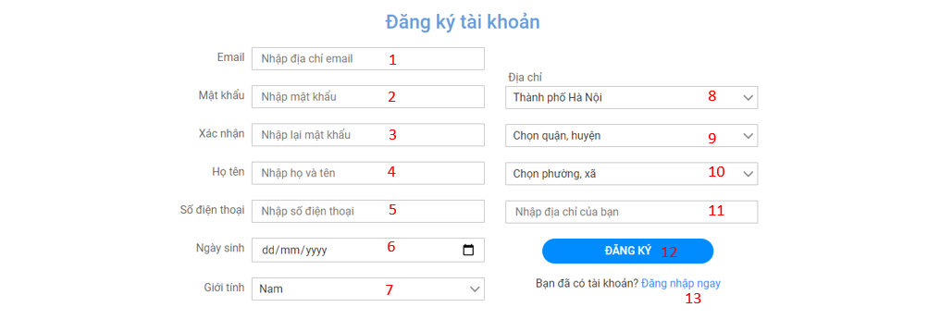

Image 4.29. Registration page

Table 4.31. Describe Registration page

|  |  |  |
| --- | --- | --- |
| **Index** | **Type** | **Meaning** |
| 1 | Input | Used to enter the Email |
| 2 | Input | Used to enter the Password |
| 3 | Input | Re-Used to enter the Password |
| 4 | Input | Used to enter the full name |
| 5 | Input | Used to enter the phone number |
| 6 | Select Options | Select a province or city |
| 7 | Select Options | Select a district |
| 8 | Select Options | Select a ward |
| 9 | Input | Used to enter building, street name |
| 10 | Input | Used to enter birthdate |
| 11 | Select Options | Select Male |
| 12 | Button | Click to sign up for an account |
| 13 | Link | Link go to login page |

##### Account navigation bar in profile page

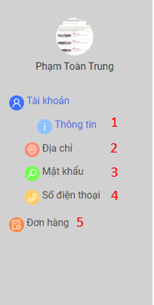

Image 4.30. Account navigation bar

Table 4.32. Describe Account navigation bar

|  |  |  |
| --- | --- | --- |
| **Index** | **Type** | **Meaning** |
| 1 | Link | Link go to account’s profile page |
| 2 | Link | Link go to account’s address page |
| 3 | Link | Link go to account’s password page |
| 4 | Link | Link go to account’s phonenumber page |
| 5 | Link | Link go to order page |

##### Account’s profile page

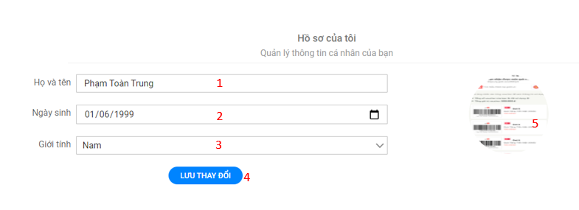

Image 4.31. Account’s profile page

Table 4.33. Describe Account’s profile page

|  |  |  |
| --- | --- | --- |
| **Index** | **Type** | **Meaning** |
| 1 | Input | Used to change full name |
| 2 | Input | Used to change birthdate |
| 3 | Input | Used to change male |
| 4 | Button | Save profile |
| 5 | Button | Button to update avatar |

##### Account’s address page

###### List addresses

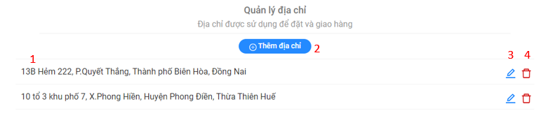

Image 4.32. List addresses

Table 4.34. Describe List addresses

|  |  |  |
| --- | --- | --- |
| **Index** | **Type** | **Meaning** |
| 1 | Table | Display list address |
| 2 | Button | Button add new address |
| 3 | Button | Button edit address |
| 4 | Button | Button delete address |

###### Add new address dialog

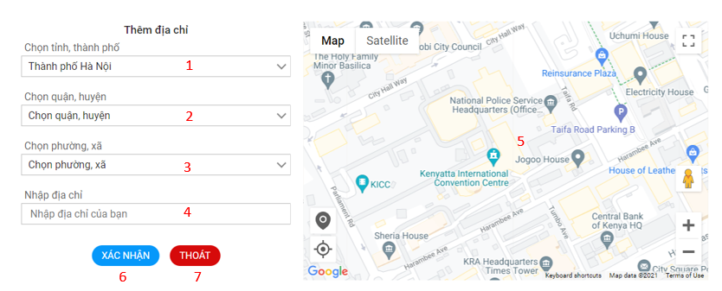

Image 4.33. Add new address dialog

Table 4.35. Describe Add new address dialog

|  |  |  |
| --- | --- | --- |
| **Index** | **Type** | **Meaning** |
| 1 | Select Options | Select a province or city |
| 2 | Select Options | Select a district |
| 3 | Select Options | Select a ward |
| 4 | Input | Used to enter building, street name |
| 5 | Map | Used to select the address manually |
| 6 | Button | Button to confirm |
| 7 | Button | Button to cancel and close dialog |

###### Edit address

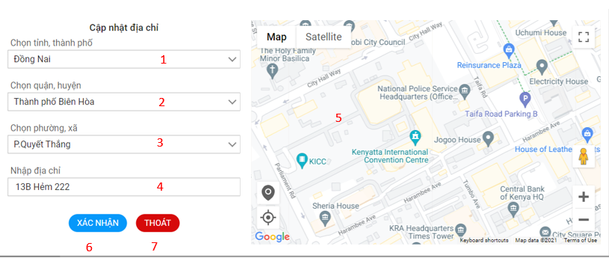

Image 4.34. Edit address dialog

Table 4.36. Describe Edit address dialog

|  |  |  |
| --- | --- | --- |
| **Index** | **Type** | **Meaning** |
| 1 | Select Options | Select a province or city |
| 2 | Select Options | Select a district |
| 3 | Select Options | Select a ward |
| 4 | Input | Used to enter building, street name |
| 5 | Map | Used to select the address manually |
| 6 | Button | Button to confirm update address |
| 7 | Button | Button to cancel and close dialog edit address |

###### Delete address dialog

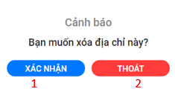

Image 4.35. Delete address dialog

Table 4.37. Describe Delete address dialog

|  |  |  |
| --- | --- | --- |
| **Index** | **Type** | **Meaning** |
| 1 | Button | Button to confirm delete address |
| 2 | Button | Button to cancel and close dialog delete address |

##### Account’s update password page

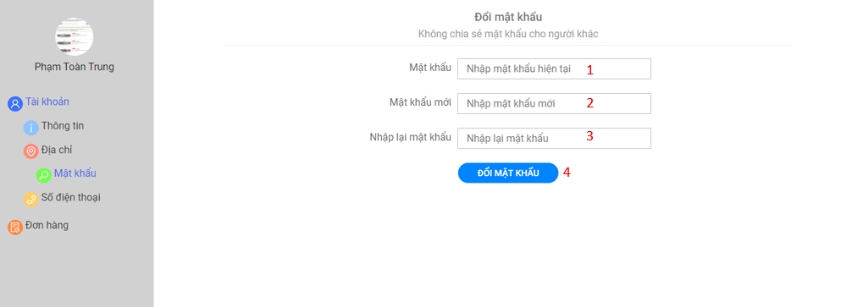

Image 4.36. Account’s update password page

Table 4.38. Describe Account’s update password page

|  |  |  |
| --- | --- | --- |
| **Index** | **Type** | **Meaning** |
| 1 | Input | Used to enter the password |
| 2 | Input | Used to enter the new password |
| 3 | Input | Re-Used to enter the password |
| 5 | Button | Confirm update password |

##### Account’s update phone number page

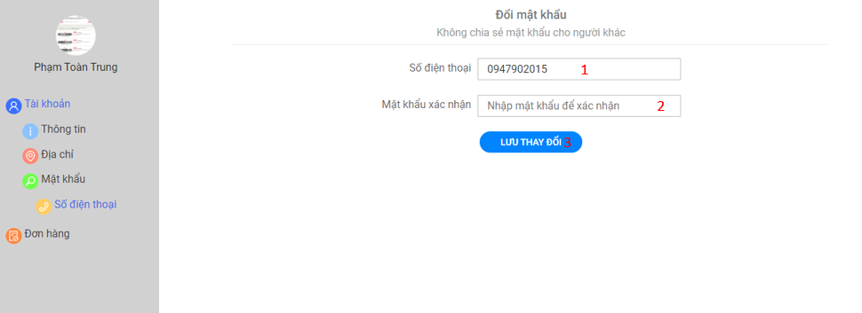

Image 4.37. Account’s update phone number page

Table 4.39. Describe Account’s update phone number page

|  |  |  |
| --- | --- | --- |
| **Index** | **Type** | **Meaning** |
| 1 | Input | Display current phone number and allows editing of phone numbers |
| 2 | Input | Used to enter the password |
| 3 | Button | Confirm update phone number |

##### Personal order page

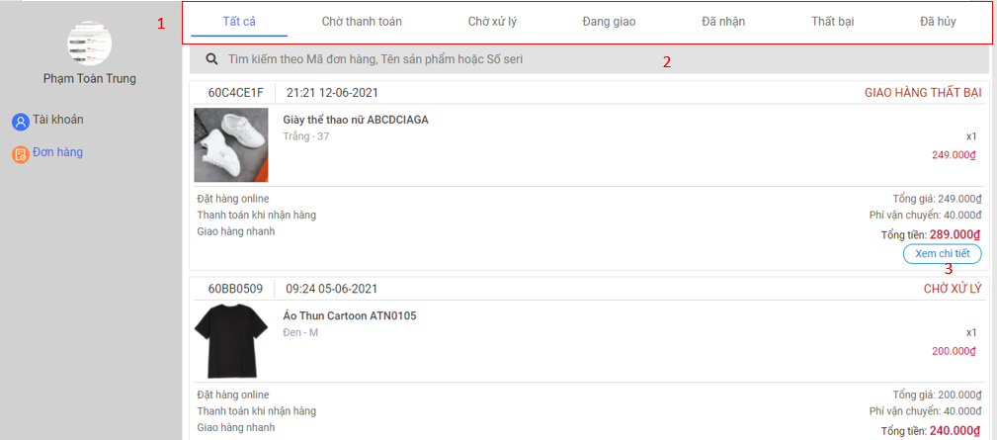

Image 4.38. Personal order page

Table 4.40. Describe Personal order page

|  |  |  |
| --- | --- | --- |
| **Index** | **Type** | **Meaning** |
| 1 | Navigation bar | Filter orders by status of order |
| 2 | Input | Used to enter the keyword need find orders |
| 3 | Button | View detail order |

##### Personal order detail page

###### Online payment method

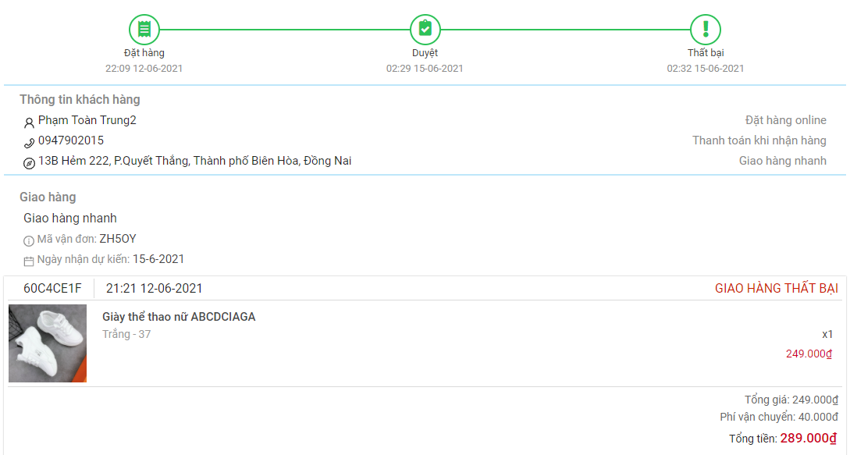

Image 4.39. Personal order detail page with online payment method of order

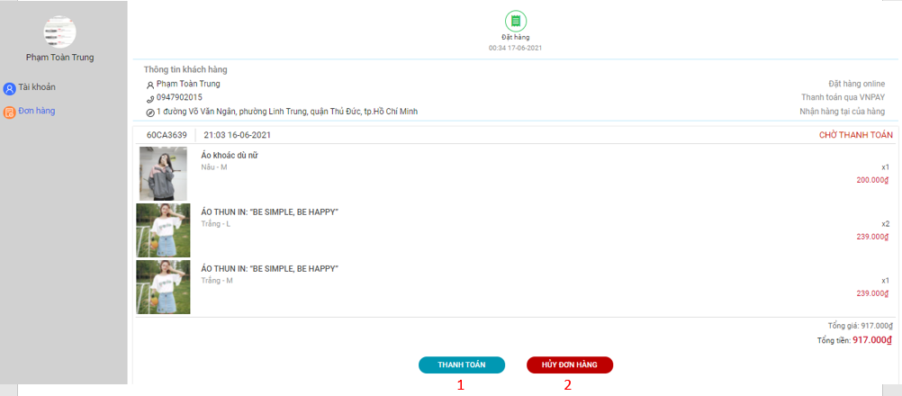

Image 4.40. Personal order detail page with online payment method of order

Table 4.41. Describe Personal order page with online payment method of order

|  |  |  |
| --- | --- | --- |
| **Index** | **Type** | **Meaning** |
| 1 | Button | Click to pay |
| 2 | Button | Click to cancel |

###### Pending approve

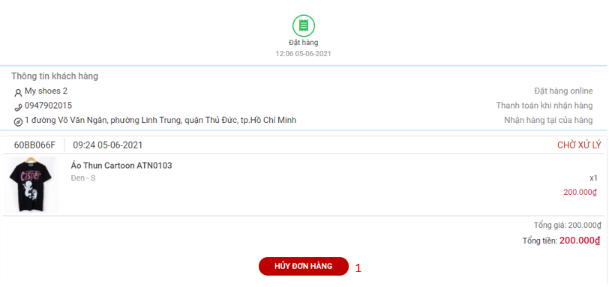

Image 4.41. Personal order detail page with pending approve status of order

Table 4.42. Describe Personal order detail page with pending approve status of order

|  |  |  |
| --- | --- | --- |
| **Index** | **Type** | **Meaning** |
| 1 | Button | Click to cancel |

##### Cart page

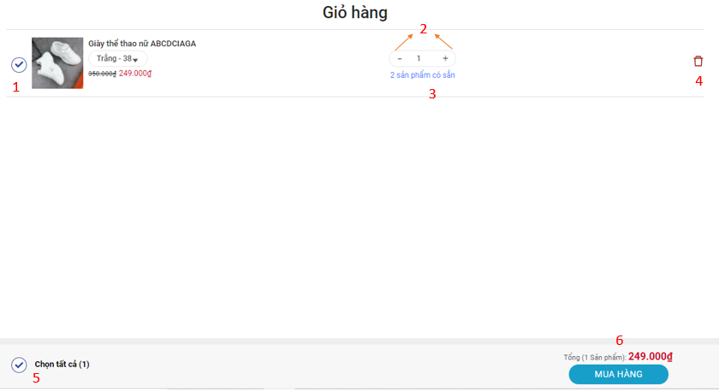

Image 4.42. Cart page

Table 4.43. Describe Cart page

|  |  |  |
| --- | --- | --- |
| **Index** | **Type** | **Meaning** |
| 1 | Check Box | Check to choose product |
| 2 | Button | Edit quantity |
| 3 | Link | Click to edit type product |
| 4 | Button | Click to delete product |
| 5 | Check Box | Check to choose all products |
| 6 | Button | Click to order |

##### View notice

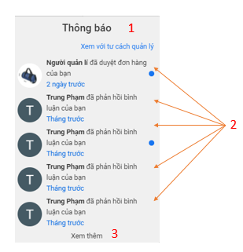

Image 4.43. Notification dialog

Table 4.44. Describe Notification dialog

|  |  |  |
| --- | --- | --- |
| **Index** | **Type** | **Meaning** |
| 1 | Link | View notice administrator(if you are an administrator) |
| 2 | Link | Link go to page have notice |
| 3 | Link | View more notice |

##### Messenger

###### View messenger

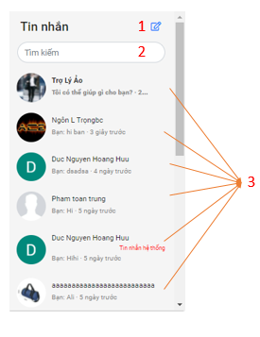

Image 4.44. Messenger dialog

Table 4.45. Describe messenger dialog

|  |  |  |
| --- | --- | --- |
| **Index** | **Type** | **Meaning** |
| 1 | Link | Open dialog to create new message |
| 2 | Input | Search message |
| 3 | Link | Open dialog to see and send message |

###### Create new message

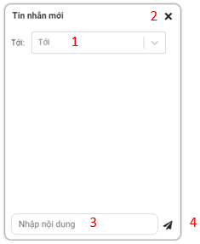

Image 4.45. Create new message dialog

Table 4.46. Describe create message dialog

|  |  |  |
| --- | --- | --- |
| **Index** | **Type** | **Meaning** |
| 1 | Select | Choose who will receive message |
| 2 | Button | Close dialog |
| 3 | Input | Used to enter the content of the message |
| 4 | Button | Used to send message |

###### Detail messages

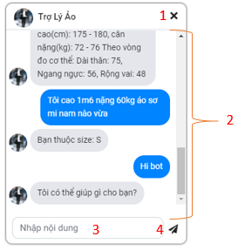

Image 4.46. Detail messages dialog

Table 4.47. Detail messages dialog

|  |  |  |
| --- | --- | --- |
| **Index** | **Type** | **Meaning** |
| 1 | Button | Close dialog |
| 2 | Text | Used to view message content |
| 3 | Input | Used to enter the content of the message |
| 4 | Button | Used to send message |

#### Admin Pages

##### Admin navigation bar

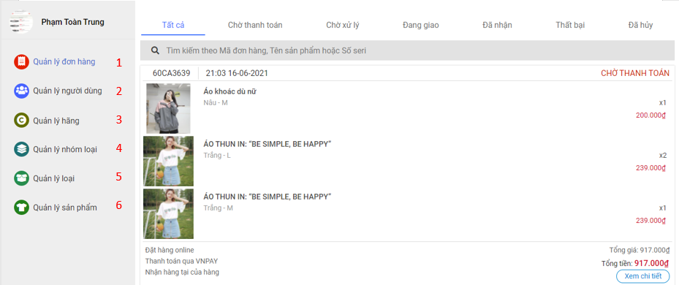

Image 4.47. Admin navigation bar

Table 4.48. Describe Admin navigation bar

|  |  |  |
| --- | --- | --- |
| **Index** | **Type** | **Meaning** |
| 1 | Link | Link go to page manage orders |
| 2 | Link | Link go to page manage users |
| 3 | Link | Link go to page manage brands |
| 4 | Link | Link go to page manage category group |
| 5 | Link | Link go to page manage category |
| 6 | Link | Link go to page manage product |

##### Orders management page

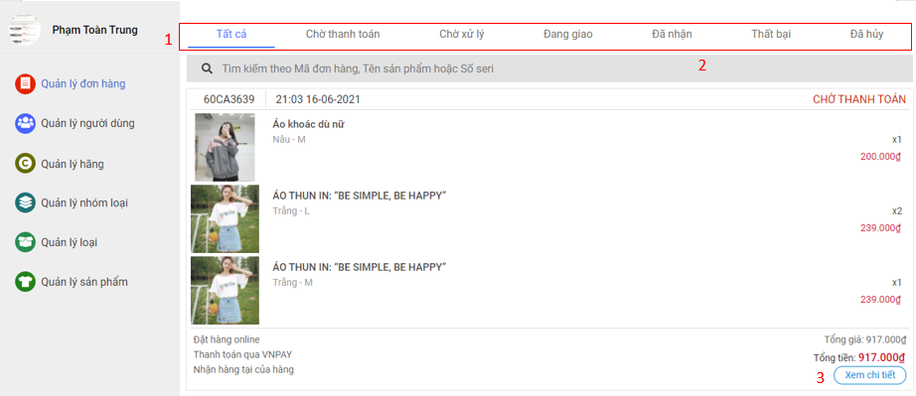

Image 4.48. Manage order page

##### Admin order detail page

Table 4.49. Describe Manage order page

|  |  |  |
| --- | --- | --- |
| **Index** | **Type** | **Meaning** |
| 1 | Navigation bar | Filter orders by status of order |
| 2 | Input | Used to enter the keyword need find orders |
| 3 | Button | View detail order |

###### Pending pay status

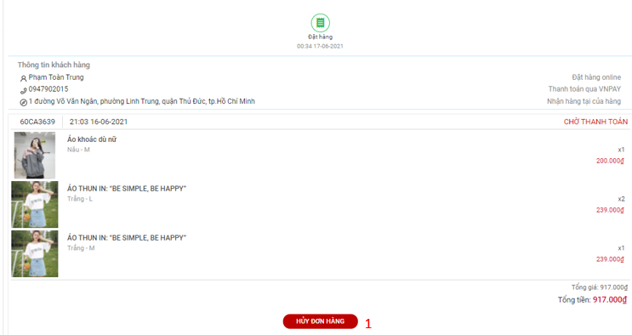

Image 4.49. Order page with pending pay status or order

Table 4.50. Describe Order page with pending pay status or order

|  |  |  |
| --- | --- | --- |
| **Index** | **Type** | **Meaning** |
| 1 | Button | Used to cancel an order |

###### Complete status

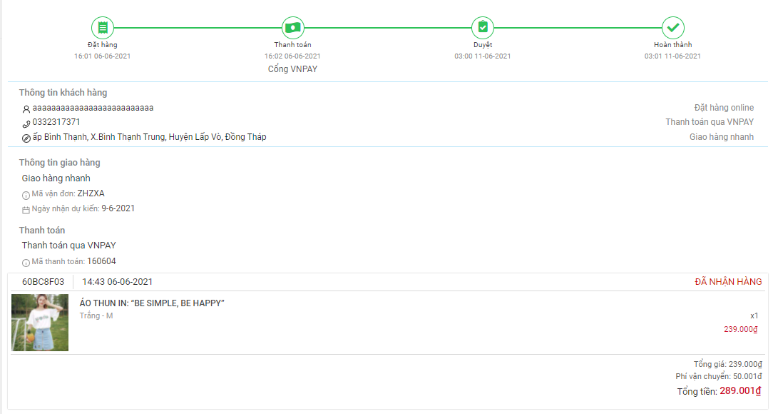

Image 4.50. Order page with complete status of order

###### Pending approve status

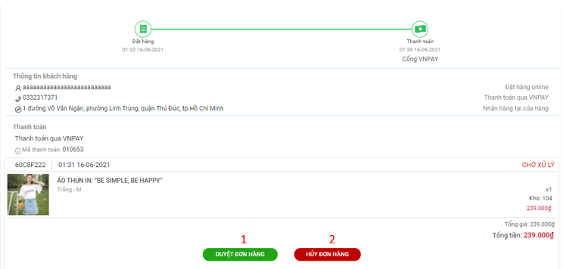

Image 4.51. Order page with pending approve status of order

Table 4.51. Describe Order page with pending approve status of order

|  |  |  |
| --- | --- | --- |
| **Index** | **Type** | **Meaning** |
| 1 | Button | Used to approve order |
| 2 | Button | Used to cancel order |

###### Delivering status

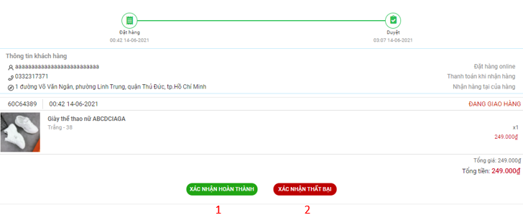

Image 4.52. Order page with delivering status of order

Table 4.52. Describe Order page with delivering status of order

|  |  |  |
| --- | --- | --- |
| **Index** | **Type** | **Meaning** |
| 1 | Button | Used to confirm completion |
| 2 | Button | Used to confirm failure |

##### Users management page

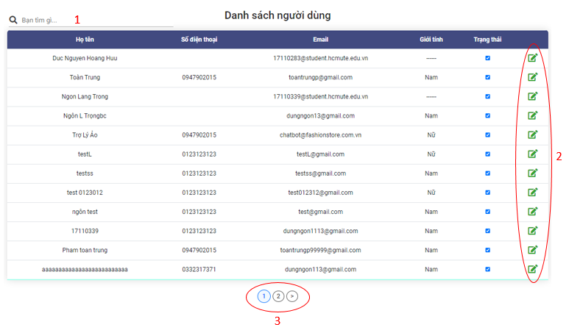

Image 4.53. User management page

Table 4.53. Describe User management page

|  |  |  |
| --- | --- | --- |
| **Index** | **Type** | **Meaning** |
| 1 | Input | Used to enter the key words to search |
| 2 | Link | Used to go to the user details management page |
| 3 | Link | Used to go to another page of the user management page |

##### User details page

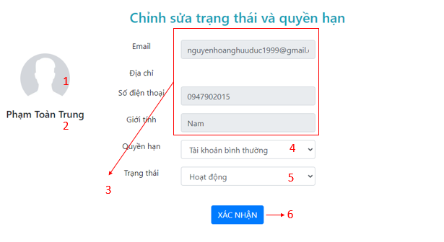

Image 4.54. User detail page

Table 4.54. Describe User detail page

|  |  |  |
| --- | --- | --- |
| **Index** | **Type** | **Meaning** |
| 1 | Image | Display the user’s avatar |
| 2 | Label | Display the user’s name |
| 3 | Input | Display the user’s email, phone number and male |
| 4 | Select option | Use to show or choose another role |
| 5 | Select option | Use to show or choose another status |
| 6 | Button | Used to confirm update the user’s role and status |

##### Brands management page

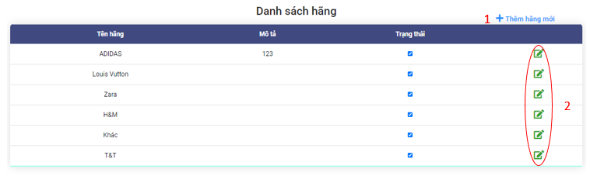

Image 4.55. Brand management page

Table 4.55. Describe Brand management page

|  |  |  |
| --- | --- | --- |
| **Index** | **Type** | **Meaning** |
| 1 | Link | Used to add new row allowing user to enter new brands. |
| 2 | Link | Used to enable row allowing user edit it. |

###### Brand management page on add status

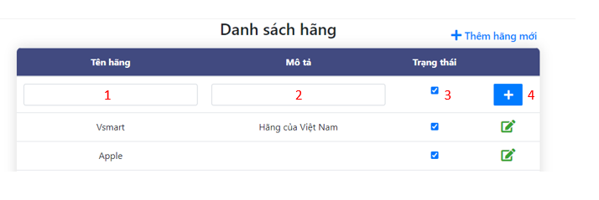

Image 4.56.Brand management page on add status

Table 4.56. Describe Brand management page on edit status

|  |  |  |
| --- | --- | --- |
| **Index** | **Type** | **Meaning** |
| 1 | Input | Used to enter the brand name |
| 2 | Input | Used to enter the brand description |
| 3 | Input | Used to choose status the brand status |
| 4 | Button | Used to add new brand |

###### Brand management page on edit status



Image 4.57. Brand management page on edit status

Table 4.57. Describe Brand management page on edit status

|  |  |  |
| --- | --- | --- |
| **Index** | **Type** | **Meaning** |
| 1 | Input | Used to edit the brand name |
| 2 | Input | Used to edit the brand description |
| 3 | Input | Used to edit status the brand status |
| 4 | Button | Used to update brand |
| 5 | Button | Used to cancel edit |

##### Products management page

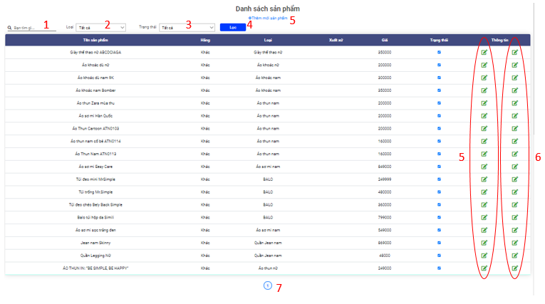

Image 4.58. Product management page

Table 4.58. Describe Product management page

|  |  |  |
| --- | --- | --- |
| **Index** | **Type** | **Meaning** |
| 1 | Input | Used to enter the key words to search |
| 2 | Select | Used to select the brand |
| 3 | Select | Used to select the status |
| 4 | Button | Used to filter results after selecting |
| 2 | Link | Used to go to the new product page |
| 3 | Link | Used to go to the product options management page |
| 4 | Link | Used to go to the product details management page |
| 5 | Link | Used to go to another page of the products management page |

##### Product options management page

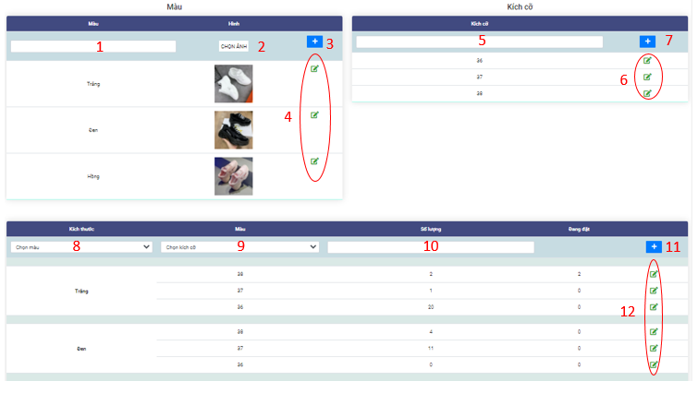

Image 4.59. Product option page

Table 4.59. Describe Product option page

|  |  |  |
| --- | --- | --- |
| **Index** | **Type** | **Meaning** |
| 1 | Input | Used to enter color |
| 2 | Button | Used to choose image of color |
| 3 | Input | Used to add new color |
| 4 | Button | Used to enable row and allowing edit color |
| 5 | Input | Used to enter the size |
| 6 | Button | Used to add new size of product |
| 7 | Button | Used to enable row and allowing edit size |
| 8 | Select | Used to select color |
| 9 | Select | Used to choose size |
| 10 | Input | User to enter quantity |
| 11 | Button | Used to add new option of product |
| 12 | Button | Used to enable row and allowing edit option of product |

##### Add product page

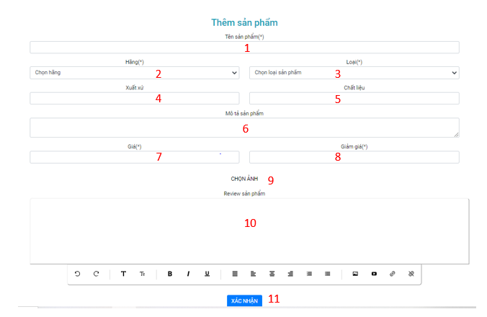

Image 4.60. Add product page

Table 4.60. Describe Add product page

|  |  |  |
| --- | --- | --- |
| **Index** | **Type** | **Meaning** |
| 1 | Input | Used to enter the product’s name |
| 2 | Input | Used to select the product’s branch |
| 3 | Input | Used to select the product’s category |
| 4 | Input | Used to enter the product’s material |
| 5 | Input | Used to enter the product’s description |
| 6 | Input | Used to enter the product’s price |
| 7 | Input | Used to enter the product’s sale off |
| 10 | Button | Used to choose the product’s image |
| 11 | Text area | Used to enter the product’s review |
| 12 | Button | Used to add new product |

### List of screens and screen flow on mobile application

Because of the specificity of the mobile app, the list of screens and the screen flow will be slightly different. But details the screens and functions similar to the website interface

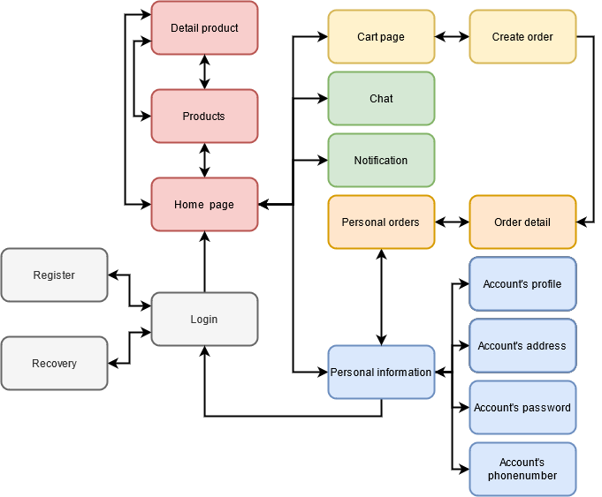

Image 4.61. Screen flow on mobile application

# INSTALLATION AND TESTING



## INSTALL APPLICATION

* Machine must have installed npm
* Machine with NodeJS installed

**Installation steps :**

In this tutorial, the group using IDE is Visual Studio Code:

Step 1:

Clone or download the project from the github link:

<https://github.com/ngonlangtrong/ClothingWebiste>

Step 2: A folder named “ClothingWebiste” will appear after cloning the project from github or extracting the report attachment. Proceed to the directory “ClothingWebiste”

Step 3: After entering the folder “ClothingWebiste”, we right click and select "Open with Code" backend directory to run the API.

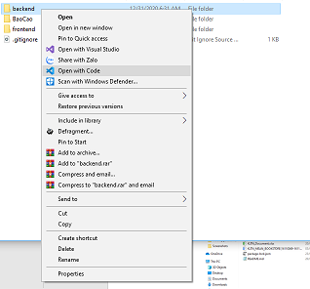

Image 5.1. Open the project backend with visual code

Step 4: After opening the project with Visual Studio Code, select "Terminal" on the taskbar, select "New Terminal" (Or simply press Ctrl + `)

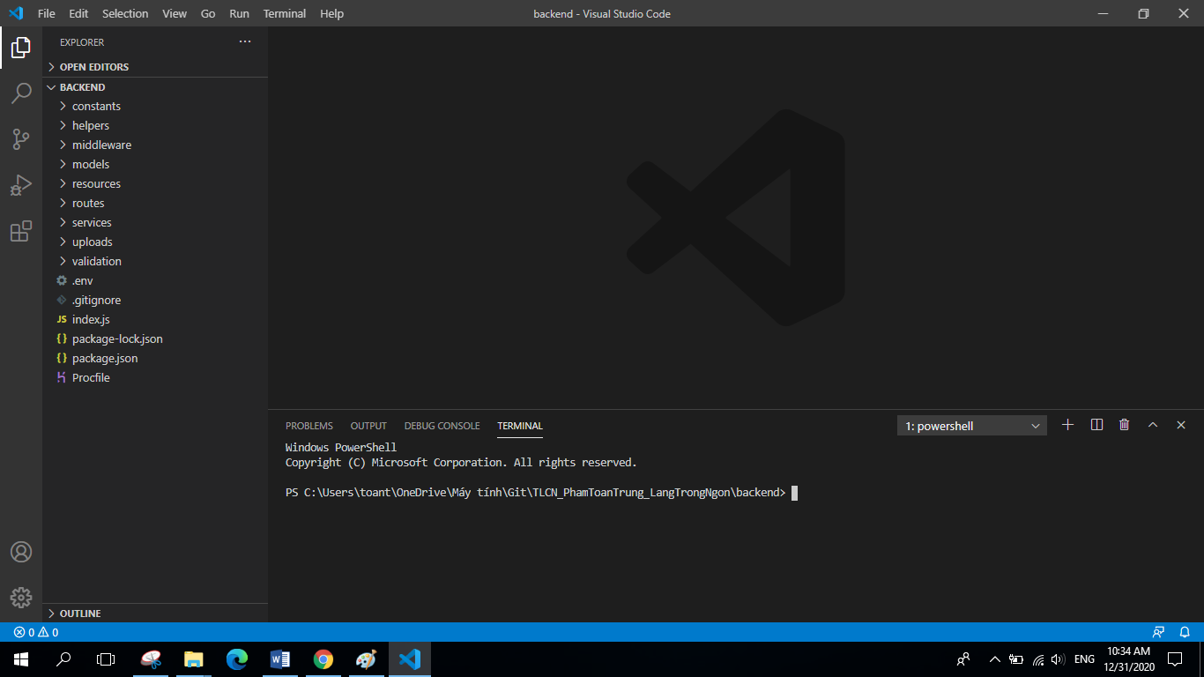

Image 5.2. Visual studio code interface

Step 5: After the integrated Command Line window appears, run the command “npm install” to update the missing libraries and packages on the computer that Project needs.

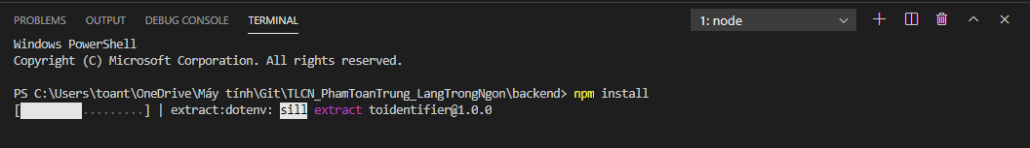

Image 5.3. Terminal window

Step 6: After the command “npm install” finishes, type the command “npm start” to run the project .

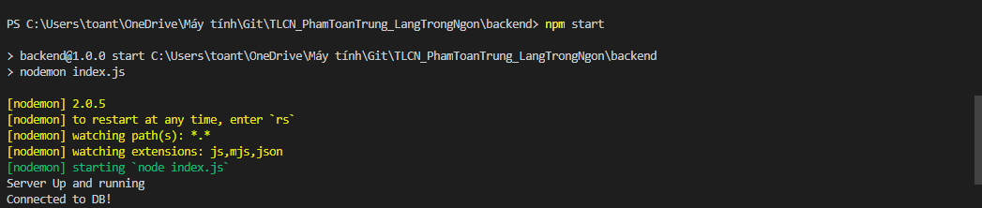

Image 5.4. The Terminal window informs that the project has been run successfully

Step 7: In the folder "ClothingWebiste", we right click and select "Open with Code" in the frontend folder to open the project containing the website interface code.

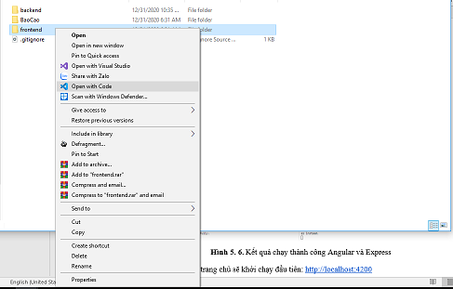

Image 5.5. Open project frontend with visual code

Step 8: Similar to steps 4, 5, 6 we open a terminal window and type the command "npm install", "npm start"

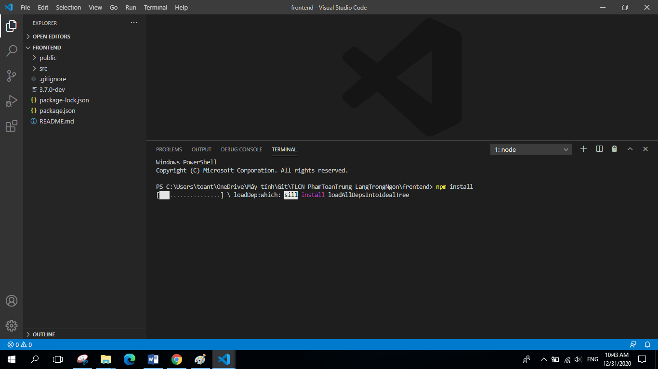

Image 5.6. The terminal is in the process of installing the missing package

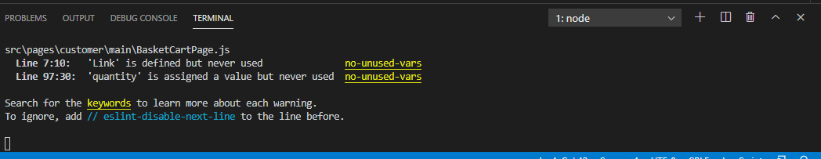

Image 5.7. Terminal window informs that the project has been run successfully

Step 9: After completing the steps on the web browser will automatically run the web page. Or you can run it manually by opening a web browser and entering url: http: // localhost: 3000

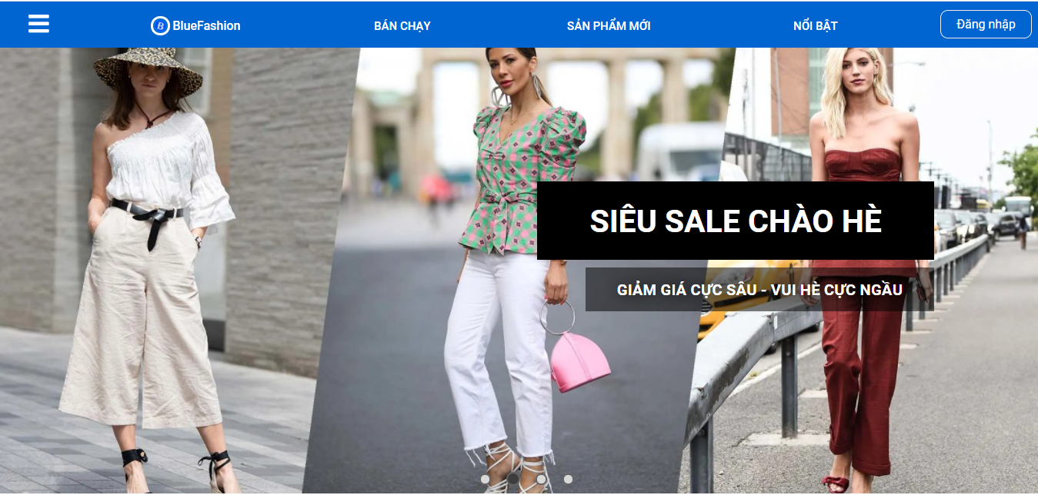

Image 5.8. The results run successfully

The home page interface will launch first: <http://localhost:3000>

## SOFTWARE TESTING

After completing the testing, the group would like to present some typical test cases.

### Registration function

Table 5.1. Software testing registry functions

|  |  |  |  |  |
| --- | --- | --- | --- | --- |
| **ID** | **Test Case Description** | **Test steps** | **Expected Output** | **Result** |
| Registration function | Sign up for an account | 1. Enter the required information on the screen: “Email”, "Mật khẩu”, “Nhập lại mật khẩu”, "Họ và tên", "Số điện thoại", "Thành phố", "Quận-huyện", "Phường-xã", "Ngày sinh", và "Giới tính"  2. Press the button “Đăng ký” | Successful registration will move to the login screen | Pass |
| SignUp_002 | Check to leave any information blank | 1. Check to leave any information blank and press the button “Đăng ký” | Please re-enter the complete information for each field | Pass |
| SignUp_003 | Check that email already exists in the system | 1. Enter the required information above and enter an email that already exists in the system  2. Press the button “Đăng ký” | The system does not allow to create an account because the email already exists and the message requires re-entering | Pass |
| SignUp_004 | Check if the Password and Confirm password are the same | 1. Enter all the information, enter “Mật khẩu” and “Nhập lại mật khẩu” khác nhau  2. Press the button “Đăng ký” | The system does not allow creating accounts because “Mật khẩu” and “Nhập lại mật khẩu” are not the same and require re-entry | Pass |

### Login function

Table 5.2. Software testing login functionality

|  |  |  |  |  |
| --- | --- | --- | --- | --- |
| **ID** | **Test Case Description** | **Test steps** | **Expected Output** | **Result** |
| SignIn _001 | Check the login without an account | 1. Enter “Email” and “Mật khẩu” were not register in the system  2. Press the button “Đăng nhập” | Displayed the notice “Email hoặc mật khẩu không chính xác!” | Pass |
| SignIn _002 | Log in with an account already in the system | 1. Enter “Email” and “Mật khẩu” registered in the system  2. Press the button “Đăng nhập” | Successful login, the system switches to the homepage | Pass |
| SignIn _003 | Login with an account already in the system but locked | 1. Enter “Email” and “Mật khẩu” registered in the system  2. Press the button “Đăng nhập” | Displayed the notice “Tài khoản đang bị khóa!” | Pass |
| SignIn _004 | Sign in but the email is not in the correct format | 1. Enter “Email” with incorrect format and “Mật khẩu”  2. Press the button “Đăng nhập” | An email message with an incorrect format appears | Pass |
| SignIn _005 | Do not enter anything | 1. Press the button “Đăng nhập” | The message asking you to enter information in the missing box appears | Pass |

### Password change function

Table 5.3. Test the password change functionality

|  |  |  |  |  |
| --- | --- | --- | --- | --- |
| **ID** | **Test Case Description** | **Test steps** | **Expected Output** | **Result** |
| ChangePass _001 | Check password change with incorrect password input | 1. Enter “Mật khẩu mới” và “Mật khẩu”  2. Press the button “Đổi mật khẩu” | Displayed the notice “Mật khẩu bạn nhập không chính xác” | Pass |
| ChangePass _002 | Check the password change with entering the correct password | 1. Enter “Mật khẩu mới” và “Mật khẩu”  2. Press the button “Đổi mật khẩu” | Displayed the notice “Đổi mật khẩu thành công” | Pass |

### Product search function

Table 5.4. Test product search functionality

|  |  |  |  |  |
| --- | --- | --- | --- | --- |
| **ID** | **Test Case Description** | **Test steps** | **Expected Output** | **Result** |
| SearchProduct _001 | Search for products already in the system | 1. Visit the home page  2. Enter product related information (name, price, brand) that exists in the search box | A list of corresponding products appears just below the search box | Pass |
| SearchProduct _002 | Search for products not already in the system | 1. Visit the home page  2. Enter non-existing product related information (name, price, brand) in the search box | Do not appear a list of corresponding products below the search box | Pass |

### Ordering functions

Table 5.5. Test order functionality

|  |  |  |  |  |
| --- | --- | --- | --- | --- |
| **ID** | **Test Case Description** | **Test steps** | **Expected Output** | **Result** |
| Order_001 | Check your order when there are no items in the shopping cart | 1. Nhấn vào giỏ hàng  2. Nhấn vào “MUA HÀNG” | Show notifications “Chưa chọn sản phẩm” | Pass |
| Order_002 | Check your order when not selected “Phương thức thanh toán” or “Phương thức nhận hàng” or “Chọn địa chỉ” | 1. Click cart  2. Press the button “MUA HÀNG”  3. Leave any request blank or all  4. Press the button “ĐẶT HÀNG” | When you click “MUA HÀNG”, there will be no response, and below the unselected request will display a message. | Pass |
| Order_003 | Check ordering when the product in stock is insufficient | 1. Click cart  2. Press the button “MUA HÀNG”  3. Enter full information of the order  4. Press the button “ĐẶT HÀNG” | Show notifications “Sản phẩm trong kho không đủ” | Pass |

### Product list filter by condition function

Table 5.6. Test product filter by condition function

|  |  |  |  |  |
| --- | --- | --- | --- | --- |
| **ID** | **Test Case Description** | **Test steps** | **Expected Output** | **Result** |
| Filter_001 | Verify that the product list filter by best sell. | 1. Visit the application website address  2. Click condition “BÁN CHẠY” in header of website | Products will are show best selling products. | Pass |
| Filter_002 | Verify that the product list filter by new product. | 1. Visit the application website address  2. Click condition “BÁN CHẠY” in header of website 3. Click sort by “SẢN PHẨM MỚI” | Products will are show new products.. | Pass |
| Filter_003 | Verify that the product list filter by featured products. | 1. Visit the application website address  2. Click condition “BÁN CHẠY” in header of website 3. Click sort by “NỔI BẬT” | Products will are show featured products. | Pass |

### Image change function when changing product colors

Table 5.7. Test image change function

|  |  |  |  |  |
| --- | --- | --- | --- | --- |
| **ID** | **Test Case Description** | **Test steps** | **Expected Output** | **Result** |
| ChangeImage_001 | Confirm the image change function when product color change works as desired | 1. Visit the application website address  2. Click to select a product from the product list  3. Click to select change product color | The product image changes to the product with the selected color | Pass |

### **Product rating function**

Table 5.8. Test product rating function

|  |  |  |  |  |
| --- | --- | --- | --- | --- |
| **ID** | **Test Case Description** | **Test steps** | **Expected Output** | **Result** |
| Rating_001 | Verify that the product review function is working as expected | 1. Visit the application website address  2. Click to select a product from the product list  3. Scroll to the Reviews section, select the stars and enter a rating  4. Click "Gửi đánh giá" | Reviews are submitted and displayed | Pass |

### **Product comment function**

Table 5.9. Test product comment function

|  |  |  |  |  |
| --- | --- | --- | --- | --- |
| **ID** | **Test Case Description** | **Test steps** | **Expected Output** | **Result** |
| CMT_001 | Confirm that the product comment function works as expected | 1. Visit the application website address  2. Click to select a product from the product list  3. Go to Comments section, enter your comment  4. Click "Thêm" | Comments are posted and displayed in the comments box | Pass |